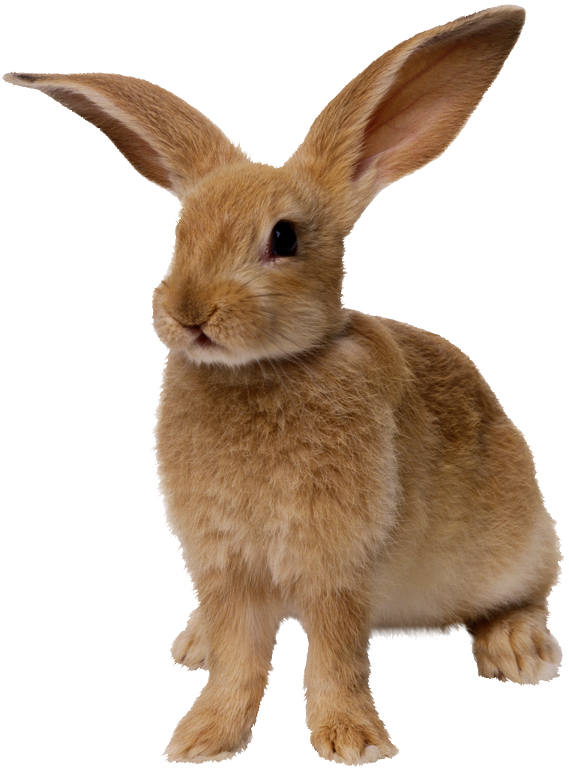
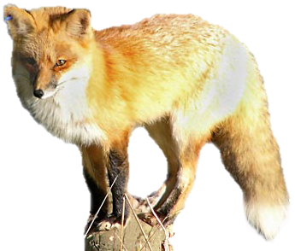
Ecosystems
Teacher’s
Guide

How Carbon cycles
and energy flows in ecosystems

The Environmental Literacy Project
Carbon: Transformations in Matter and Energy
(Carbon TIME)
2012-2013

Table of Contents
Table of Contents 2
Unit and Program Overview 3
Specifications for Ecosystems Unit 6
Ecosystems Unit At a Glance 6
Learning Objectives for Middle and High School Students 7
Timeline and Overview 8
Additional Ecosystems Unit Information 12
Vocabulary 12
Materials 12
Acknowledgments: 12
Lesson 1: Unit Pre-Test and Carbon in Our Ecosystems 13
Activity 1: Unit Pre-Test 14
Ecosystems Unit Pre- and Post-test 15
Ecosystems Unit Pre- and Post-test with Commentary 18
Activity 2: Where Is The Carbon in Ecosystems? 20
Lesson 2: Sunny Meadows Investigation 22
Sunny Meadows Investigation Worksheet 26
Assessing Sunny Meadows Investigation Worksheet 28
Lesson 3: Matter Cycles and Energy Flows In Ecosystems 31
Activity 1: The Three Questions at the Large-Scale 33
Activity 2: Carbon Dice Game 35
Activity 3: Tracing Carbon: The Answer to the Carbon/Movement Question 37
Tracing Carbon Paths Worksheet 39
Assessing Tracing Carbon Paths Worksheet 42
Activity 4: Tracing Energy: The Answer to the Energy Question 45
Tracing Energy Worksheet 47
Assessing: Tracing Energy Worksheet 49
The Three Questions: Large Scale Version 51
Lesson 4: Carbon Pools And Fluxes 52
Activity 1: Why Are Carbon Pools Different Sizes? 54
Why are Carbon Pools Different Sizes? Worksheet 55
Assessing: Why are Carbon Pools Different Sizes? Worksheet 57
Activity 2: Carbon Pools and Fluxes 59
Carbon Pools and Fluxes Worksheet 60
Carbon Atom Cards 61
Assessing Carbon Pools and Fluxes Worksheet 62
Optional Activity 3: Measuring Carbon Pools and Fluxes Reading 63
Measuring Pools and Fluxes Reading 64
Lesson 5: Ecosystems Applications 66
Activity 1: Farm Ecosystems 66
Farm Ecosystem Worksheet 69
Activity 2: Landscape Changes and Carbon in Ecosystems 70
Activity 3: Ecosystems Unit Post-Test 72
Grading the Ecosystems Unit Pre- and Post-test 73

Unit and Program Overview

Ecosystems is one in a series of six units (Systems and Scale, Animals, Plants, Decomposers, Ecosystems, Human Energy Systems) developed by the Carbon: Transformations in Matter, and Energy (Carbon TIME) Project. In the Carbon TIME project we are developing a series of six teaching modules that can be used at the middle school or high school level. They are based on research focusing on learning progressions leading to environmental science literacy, described below. The purpose of these units is to enable students to uncover the chemical basis of life and lifestyles.
Key scientific ideas about carbon-transforming processes. The chemical basis of life and lifestyles lies in carbon-transforming processes in socio-ecological systems at multiple scales, including cellular and organismal metabolism, ecosystem energetics and carbon cycling, carbon sequestration, and combustion of fossil fuels. These processes: (a) create organic materials (photosynthesis), (b) transform organic materials (biosynthesis, digestion), and (c) oxidize organic materials (cellular respiration, combustion). We think that it is important for students to understand carbon-transforming processes for many reasons; among them: the primary cause of global climate change is the current worldwide imbalance among these processes.
The reason these processes are unbalanced lies in the nature of organic materials: foods, fuels, and biomass (the tissues of living and dead organisms). All organic materials contain carbon and hydrogen, and store chemical energy in their carbon-carbon and carbon-hydrogen bonds that can be released when those materials combine with oxygen.
Virtually all of the chemical energy on Earth is stored in organic materials, and we need that chemical energy to maintain our lifestyles, so we burn organic materials—especially fossil fuels. So understanding these process is essential for students to act as informed citizens—what we call environmental science literacy.
Describing student learning in terms of learning progression levels. We have found that in order to achieve our program goals, students must learn new knowledge and practices—the science content described above. Underlying those changes, however, is an even more fundamental kind of learning—what we refer to as mastering scientific discourse.
Our everyday accounts of carbon-transforming processes are based on force-dynamic discourse or reasoning. Force-dynamic reasoning construes the events of the world as caused by actors (including people, animals, plants, machines, and flames), each with its own purposes and abilities, or by natural tendencies of inanimate materials. In order to accomplish their purposes, the actors have needs or enablers that must be present. For example, force-dynamic reasoning explains the growth of a tree by identifying the actor (the tree), its purpose (to grow), and its needs (sunlight, water, air, and soil). Force-dynamic predictions involve identifying the most powerful actors and predicting that they will be able to overcome antagonists and achieve their purposes as long as their needs are met.
This approach to reasoning about socio-ecological processes contrasts sharply with principled scientific discourse, which construes the world as consisting of hierarchically organized systems at different scales. Rather than identifying the most powerful actors, scientific reasoning sees systems as constrained by fundamental laws or principles, which can be used to predict the course of events. Each of our learning progressions involves students learning to apply fundamental scientific principles to the phenomena of the world around them.
So it is useful to think of learning science as like learning a second language. Students at the beginning of the learning progression are monolingual: They have mastered force-dynamic discourse but know little of the nature and power of scientific discourse. So our goal is to help students become “bilingual,” able to use force-dynamic or scientific discourse as the occasion demands. This is a difficult goal in part because force-dynamic and scientific discourse often use the same words (e.g., energy, growth, food, nutrient, matter) with different meanings. The differences can remain hidden to both teachers and students, creating the appearance of common understanding while profound differences remain.
We define students’ progress toward mastering scientific knowledge, practices, and discourse in terms of four levels of achievement, ranging from Level 1 (completely dependent on force-dynamic discourse) to Level 4 (able to choose between force-dynamic and principled scientific accounts of carbon-transforming processes). Very briefly, the levels we have identified are as follows:
Level 1: Pure force-dynamic accounts: Students have no choice but to rely on force-dynamic discourse. Their accounts focus on actors, enablers, and natural tendencies of inanimate materials, using relatively short time frames and macroscopic scale phenomena.
Level 2: Elaborated force-dynamic accounts: Students’ accounts continue to focus on actors, enablers, and natural tendencies of inanimate materials, but they add detail and complexity, especially at larger and smaller scales. The include ideas about what is happening inside plants and animals when they grow and respond, for example, and they show awareness of larger scale connections among phenomena such as food chains and how decay enriches the soil.
Level 3: Incomplete or confused scientific accounts: Students show awareness of important scientific principles and of models at smaller and larger scales, such as cells, atoms and molecules, and cycling of gases and materials in ecosystems. They have difficulty, though, connecting accounts at different scales and applying principles consistently. In particular, they often confuse matter and energy and fail to account for the mass of gases in their accounts.
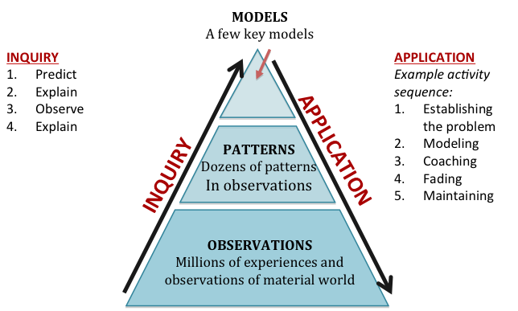
Level 4: Coherent scientific accounts: Students successfully apply fundamental principles such as conservation of matter and energy to phenomena at multiple scales in space and time. In general, our descriptions of Level 4 performances are consistent with current national science education standards and with the draft framework for new standards.
Purpose and structure of Carbon TIME units. Each of our six units (Systems and Scale, Animals, Plants, Decomposers, Ecosystems, Human Energy Systems) focuses on familiar systems and events that involve carbon-transforming processes. Each unit is designed to help students at Level 2 in the learning progression (the most common starting point for middle school and high school students) advance to Level 3 or Level 4.
Instructional model for teaching units
All of the units focus on conservation of matter and energy as fundamental principles, and all follow a general instructional model (see figure) that engages students in both inquiry and application (accounts) practices. Teaching of application practices is based on a cognitive apprenticeship model: (a) students are put in situations where they can observe other people engaging in the activity—modeling, (b) the students engage in the practice with scaffolding or support from others—coaching, and (c) the support is gradually withdrawn until the students are independently engaged in the practice—fading.
The central role of the Three Questions. We believe that we can help students move to higher levels in the learning progression most effectively by focusing both the inquiry and application sequences on Three Questions. The Three Questions are slightly different in the large-scale units (Ecosystems and Human Energy Systems). These questions along with rules that we will expect students to follow and evidence we will expect them to look for in answering them, are presented in Table 1 below.
Table 1: The Three Questions: Large-Scale Version
Question | Rules to Follow | Evidence to Look For
The Location Question: Where are the available carbon atoms in our environment?  What pools of materials are they in? | Atoms endure.  Carbon atoms stay in pools unless a process moves them in or out. | The air has carbon atoms in CO₂  Organic materials are made of molecules with carbon atoms  - Fuels  - Living and dead plants and animals (including foods)_
The Carbon/Movement Question: How/why do carbon pools change over time?  How are carbon atoms moving? | Carbon-transforming processes move carbon atoms among pools  Carbon atoms cycle within environmental systems | Evidence of carbon-transforming processes:  - organisms eating, growing, breathing, dying  - decay  - combustion  If a carbon pool size changes, that means carbon atoms moved
The Energy Question: What is happening to chemical energy?  How does energy flow through environmental systems? | Carbon-transforming processes change energy from:  - sunlight to  - chemical energy to  - heat radiated into space  Energy flows through environmental systems | We can observe indicators of different forms of energy  - Organic materials with chemical energy  - Light  - Heat energy  - Work or motion energy

Comments on goals based on the Three Questions. Our focus on the Three Questions arises from our reading of the data from the first pilot tests of our units during the 2011-12 school year, as well as our reading of data from other projects (e.g., Jin & Anderson, in press). We are convinced that our first priority for student learning should be to engender a sense of necessity about conservation of matter and energy, along with the ability to apply these principles to carbon-transforming processes. The essential understandings that students should have from Ecosystems are summarized in the three columns of the Three Questions Poster—Table 1 above, which is available as a handout in Lesson 3, Activity 4.

Specifications for Ecosystems Unit
Ecosystems builds on student learning in Systems and Scale, Animals, Plants and Decomposers about organic and inorganic materials, how all systems exist at multiple scales, and transformation of materials and energy during chemical change. In Ecosystems students learn how the carbon–transforming processes of photosynthesis, cellular respiration, digestion and biosynthesis along with the processes of eating, death and defecation are occurring at an ecosystem scale and are responsible for the cycling of carbon and flow of energy in ecosystems.

Ecosystems Unit At a Glance

Lesson 1: Unit Pre-test and Carbon in Our Ecosystems | Time Estimate
Activity 1: Ecosystems Unit Pre-Test | 20 min
Activity 2: Where is the Carbon in Ecosystems? | 20 min
Lesson 2: Sunny Meadows Investigation
Activity 1: Sunny Meadows Investigation | 35 min
Activity 2: Comparing Different Ecosystems | 20 min
Lesson 3: Matter Cycles and Energy Flows in Ecosystems
Activity 1: The Three Questions for the Large-Scale | 15 min
Activity 2: Carbon Dice Game | 30 min
Activity 3: Tracing Carbon: The Answer to the Carbon/Movement Question | 30 min
Activity 4: Tracing Energy: The Answer to the Energy Question | 30 min
Lesson 4: Carbon Pools and Fluxes
Activity 1: What Happens When Carbon Pools Change Size? | 35 min
Activity 2: Carbon Pools and Fluxes | 40 min
Lesson 5: Ecosystems Applications
Activity 1: Farm Ecosystems | 30 min
Activity 2: Landscape Changes and Carbon in the Ecosystem | 20+ mins
Activity 5: Animals Unit Post-Test | 20 min

Learning Objectives for Middle and High School Students
The table below lists the key goals for student learning in terms of application and citizenship practices and the challenges that those goals pose for Level 2 students (including most middle school students and many high school students and Level 3 students (including some high school students).
Type of Objective | Learning Objective | Challenges for Level 2 Students | Challenges for Level 3 Students
Application: Location Question | Locate organic and inorganic carbon pools in natural ecosystems (e.g., meadow) and human-managed ecosystems (e.g., farm):  - CO₂ in the atmosphere  - Organic carbon pools: producers, herbivores, carnivores, soil carbon  Describe the “biomass pyramid” (producers > herbivores > carnivores) as a consistent pattern in terrestrial ecosystems  Describe pools as changing in size over time | Level 2 students will think of carbon a kind of material rather than as an atom in many carbon-containing molecules. | Level 3 students may not think of the same carbon atoms in the atmosphere, biomass, and soil
Application: Movement/Carbon Question | Describe carbon cycling within ecosystems as movement of carbon atoms among carbon pools associated with:  - Movement of materials: Eating, defecation, death  - Carbon-transforming processes: combustion, photosynthesis, digestion, biosynthesis, cellular respiration  Explain why the biomass pyramid is a consistent pattern in terrestrial ecosystems.  Explain changes in size of carbon pools in terms of fluxes into and out of carbon pools | Level 2 students will explain ecosystem processes as series of causally connected events (rabbits eat grass; foxes eat rabbits) | Level 3 students will recognize fluxes as involving movements of matter, but not that fluxes BOTH make one pool larger AND make another pool smaller.
Application: Energy question | Identify energy transformations involved in carbon fluxes  Describe energy as flowing through ecosystems, from sunlight to chemical energy to heat that is radiated into space | Level 2 students will describe energy as a cause of events rather than a conserved entity that can be traced through systems. | Level 3 students are likely to describe energy as recycling in ecosystems (e.g., through soil nutrients)
Citizenship decision-making | Explain the implications for resource use of humans eating meat or plant products: The same producers can support more humans as herbivores than as carnivores. | Level 2 students will think of diets as “good” or “bad,” but on the basis of health or general moral virtue, rather than reasoning about food chains. | Level 3 students may identify vegetarian diets as “better for the environment,” but their scientific rationale may be associated with more general notions of environmental harm.

Timeline and Overview
The table below summarizes the sequence of unit activities, showing how they address the inquiry and application goals and how they fit into the instructional model for the unit.
Structure and Sequence | Guiding Question | Activity Description | Learning Objectives | Background Information
Lesson 1: Unit Pre-Test and Carbon in Our Ecosystems
Guiding Question: Where is the carbon located in an ecosystem?
Lesson Description: In this lesson students take a pre-test and then share their ideas about where carbon is in ecosystems, identifying which carbon is organic versus inorganic, and identifying the type of organisms (producers, consumers, carnivores and decomposers) that exist in ecosystems.
Activity 1: Unit Pretest  20 min | Where is the carbon located in an ecosystem? | Students complete a pretest assessing their ideas about carbon in ecosystems | Students express their own ideas about how carbon cycles and energy flows in ecosystems during the pre-test. | Students’ responses will provide information about how they reason about carbon in ecosystems (see comments on pretest) and a starting point for unit discussions.
Activity 2: Where is the carbon located in an ecosystem?  20 min | Where is the carbon located in an ecosystem? | In this activity students identify which carbon is organic versus inorganic, and identify the type of organisms (producers, consumers, carnivores and decomposers) that exist in ecosystems. | Students will share and record the classes’ initial ideas about where carbon exists in ecosystems. | This activity was designed to introduce students to some of the abstract ideas involved in thinking about carbon on an ecosystem-scale, including the concept of an “ecosystem,” moving to population (instead of individual organism) level thinking, and lumping together species in ecosystems that have similar roles.
Lesson 2: Sunny Meadows Investigation
Guiding Question: How do organic carbon pools change over time in ecosystems? What is the pattern of organic carbon pool size that happens in ecosystems?
Lesson Description: Students examine the substances that make up the common foods we ingest, group them into “organic” and “inorganic” and re-visit how these materials relate to chemical energy. Students take a closer look at water—an inorganic substance that contributes to mass but not biomass.
Activity 1: Sunny Meadows Investigation  35 min | How do organic carbon pools change over time in ecosystems? | In this lesson students use an online simulation allows students to run multiple scenarios over and over again, essentially hypothesizing, testing, and hypothesizing again until students begin to see patterns in the way the ecosystem changes as populations change. | Students will describe the “biomass pyramid” (producers > herbivores > carnivores as a consistent pattern in terrestrial ecosystems and describe pools as changing in size over time, and describe pools as changing in size over time. | Through the online simulations students will need to make two observations: 1) the size of any given carbon pool changes over time, 2) there is a consistent pattern of biomass size for producers, herbivores and carnivores compared to each other.
Activity 2: Comparing Different Ecosystems  20 min | What is the pattern of organic carbon pool size that happens in ecosystems? | In this activity students observe the same pattern in producers, consumers and carnivores in four different types of ecosystems. Students also observe that the size of the soil organic carbon pool is larger than the producer pool. | Describe the “biomass pyramid” (producers > herbivores > carnivores as a consistent pattern in terrestrial ecosystems. | Students may see water as a food, although, in a strict sense, water is not food in that it does not increase an organism’s mass in the long-term. Some students idea of “energy” may include anything that gives vitality to an organism, which may include water, however water does not provide chemical energy to organisms. Foods and organisms have a lot of water that contributes to mass, but that is not a part of biomass.
Lesson 3: Matter Cycles and Energy Flows in Ecosystems
Guiding Question: How do carbon atoms and energy move through an ecosystem?
Lesson Description: In this lesson, students are introduced to the Three Questions at a Large-Scale Framework. They will find that the first question, the Location Question, was answered during Lesson 2. The second and third questions, the Carbon/Movement Question and the Energy Question, are answered in the activities of Lesson 3.
Activity 1: The Three Questions  15 min | How do organic carbon pools change over time in ecosystems? | In this lesson, students are introduced to the Three Questions at a Large-Scale Framework. They will find that the first question, the Location Question, was answered during Lesson 2. The second and third questions, the Carbon/Movement Question and the Energy Question, are answered in the activities of Lesson 3 (Activity 2-4). | Share and record the classes’ initial ideas about the Three Questions at the Large-Scale. | In these lessons, students are introduced to how carbon cycles and energy flows in an ecosystem by playing the Carbon Dice Game and answering the Three Questions at a Large-Scale.
Activity 2: Carbon Dice Game  30 min | How do carbon atoms and energy move through an ecosystem? | Students play the Carbon Dice Game, acting out the pathways for carbon atoms and energy in a meadow ecosystem. | Observe how carbon cycles and energy flows through an ecosystem. | The Carbon Dice Game helps students think about how carbon is cycled through different organisms in an ecosystem, and the processes that contribute to the transformation of carbon from one form to another: eating, digestion, biosynthesis, photosynthesis, cellular respiration and death/defecation. The game models the partitioning of matter in individual organisms into digestion/biosynthesis, cellular respiration, being eaten or death/defecation. The activity uses dice to represent the likelihood of a given carbon atom to be used to build mass in an organism or to be released back into the atmosphere as a product of cellular respiration.
Activity 3: Tracing Carbon: The Answer to the Carbon Question  30 min | How do carbon atoms and energy move through an ecosystem? | Students will describe carbon cycling within ecosystems as movement of carbon atoms among carbon pools associated with:  Movement of materials: 1) Eating, defecation, death and 2) Carbon-transforming processes: combustion, photosynthesis, digestion, biosynthesis, cellular respiration | Observe how carbon cycles and energy flows through an ecosystem. | By answering the Three Questions students will notice that carbon atoms move between pools via carbon transforming processes and that when one pool increases, another pool must decrease. They will also observe that not all matter from lower trophic levels is passed on to consumers at higher trophic levels, and instead a lot of carbon ends up in the atmosphere and in soil organic carbon.
Activity 4: Tracing Energy: The Answer to the Energy Question  30 min | How do carbon atoms and energy move through an ecosystem? | Students will identify energy transformations involved in carbon fluxes and describe energy as flowing through ecosystems, from sunlight to chemical energy to heat that is radiated into space. | Observe how carbon cycles and energy flows through an ecosystem. | Students will observe how energy is transformed from sunlight to chemical energy in producers and transferred between organisms during eating and death, and then transformed into heat energy during cellular respiration in an ecosystem.
Lesson 4: Carbon Pools and Fluxes
Guiding Question: How do carbon pools change over time?
Lesson Description: In this lesson, students follow how carbon pools change in size as carbon atoms move in and out of each pool due to eating, digestion, biosynthesis, photosynthesis, cellular respiration and death/defecation, and students keep an accounting of carbon pool size changes over time due to changes in carbon fluxes (carbon movement over time).
Activity 1: Why are carbon pools different sizes?  35 min | Why are carbon pools different sizes? | Students will follow how carbon pools change in size as carbon moves in and out of each pool due to eating, digestion, biosynthesis, photosynthesis, cellular respiration and death/defecation. The teacher will use a Powerpoint presentation as students keep an accounting on a worksheet. | Students will explain why the biomass pyramid is a consistent pattern in terrestrial ecosystems. | Students will explain the reason for the pattern of size of carbon pools that was observed in Sunny Meadows and the Carbon Dice Game. In order to explain the “biomass pyramid” students need to think about movement of carbon in semi-quantitative ways. Most of the carbon that enters ecosystems as organic carbon during photosynthesis is used for cellular respiration (energy needs) in organisms and returns to the atmosphere. Because most of the organic carbon in a organism is used for cellular respiration (and much of it is lost during death and defecation), very little organic carbon is available to be passed from one level in a food chain to another.
Activity 2: Carbon Pools and Fluxes  40 min | How do carbon pools change over time? | Students will predict how carbon pool size changes over time with different fluxes. The teacher will use a Powerpoint presentation as students work through three “Rounds” of a worksheet. Students use “Carbon atom cards” (or blocks of 100 carbon atoms) to keep an accounting of carbon pool size changes over time due to changes in carbon fluxes. | Explain changes in size of carbon pools in terms of fluxes into and out of carbon pools. | In the Unit so far we have talked about the movement of carbon from one pool to another without specifically talking about time. Fluxes are the amount of carbon that moves over time. In this lesson we talk about the movement of carbon that occurs within one year (a flux) and how that influences the size of carbon pools over time. In this lesson we also simplify the number of pools to only organic carbon in living organisms and soil carbon and inorganic carbon in the atmosphere, and carbon transforming processes to only photosynthesis and respiration.
Opt Activity 3: Measuring Carbon Pools and Fluxes Reading  20 min | How do carbon pools change over time? | Students are assigned a reading that helps them understand how carbon fluxes and carbon pools are measured in ecosystems. | Students will explain why the biomass pyramid is a consistent pattern in terrestrial ecosystems. | Scientists are very interested in carbon movement in ecosystems. There are many techniques that have been developed to measure how carbon in ecosystems changes location, how rates of carbon movement change, and how carbon pools change in size. This reading describes the work of one scientist who studies carbon pools and fluxes.
Lesson 5: Ecosystems Applications
Guiding Question: How does carbon cycling apply to real-world situations?
Lesson Description: Students consider how many people can be supported on a vegetarian diet versus a meat-based diet. Students use historical aerial photos from Google Earth to apply their knowledge of carbon cycling in ecosystems to various situations. The final activity for the Unit is a Post-test.
Activity 1: Farm Ecosystems  30 min | How does carbon cycling apply to real-world situations? | Students consider how many people can be supported on a vegetarian diet versus a meat-based diet. Students account for carbon in both of these situations on a worksheet, while following along with a Powerpoint presentation. | Explain the implications for resource use of humans eating meat or plant products: The same producers can support more humans as herbivores than as carnivores. | Students consider several real world situations to apply their understanding of ecosystems and carbon cycling. Thinking about real-world situations will help students practice their knowledge and help students understand the relevance of this topic.
Activity 2: Landscape Changes and Carbon in the Ecosystem  20+ mins | How does carbon cycling apply to real-world situations? | Students use historical aerial photos from Google Earth to apply their knowledge of carbon cycling in ecosystems to various situations. Students examine images and answer a set of questions. This activity could also have a portion where students go outside to compare aerial photos to what they see on the landscape (optional). | Students will explain changes in size of carbon pools in terms of fluxes into and out of carbon pools. | Students consider several real world situations to apply their understanding of ecosystems and carbon cycling. Thinking about real-world situations will help students practice their knowledge and help students understand the relevance of this topic.
Activity 3: Ecosystems Unit Post-test  20 min | What have students learned about carbon cycling and energy flowing in ecosystems? | Students retake the pretest that they took at the beginning of the unit and assess what they have learned. | Take a test that assesses most key learning objective for the unit. | The Post-test is a summative assessment activity. You can track students’ progress by having them retake the unit pre-test as a post-test and comparing the results of the two assessments.

Additional Ecosystems Unit Information

Targeted Grades: 6-12

Key Concepts: Biomass Pyramid, Large-Scale Carbon Cycling in Ecosystems, Carbon Pools & Fluxes, Carbon Transforming Processes, Large-Scale Energy in Ecosystems

Vocabulary
- Biomass
- Biomass Pyramid
- Biosynthesis
- Carbon Cycle
- Carbon Flux
- Carbon Pool
- Cellular Respiration
- Chemical Energy
- Combustion
- Consumer
- Decomposer
- Defecation
- Digestion
- Ecosystem
- Energy Pyramid
- Inorganic Matter
- Meat-based Diet
- Organic Carbon
- Inorganic Carbon
- Organic Matter
- Photosynthesis
- Plant-based Diet
- Producer

Materials

Acknowledgments:
Writers: Jenny Dauer, Charles W. (Andy) Anderson, Hannah Miller

Reviewers and assistance from: Amy Lark, Lindsey Mohan, Li Zhan

Lesson 1: Unit Pre-Test and Carbon in Our Ecosystems
Role of this Lesson in the Unit Sequence
Activity 1: Formative assessment
Activity 2: Foundational Skills and Knowledge about Ecosystems

Duration: 40 minutes
Activity 1: Ecosystems Unit Pre-test ~20 minutes
Activity 2: Where Is The Carbon in Ecosystems? ~20 minutes

Guiding Question: Where is the carbon located in an ecosystem?

Lesson Description:
In this lesson students take a pre-test and then share their ideas about where carbon is in ecosystems, identifying which carbon is organic versus inorganic, and identifying the type of organisms (producers, consumers, carnivores and decomposers) that exist in ecosystems.

Learning Objectives:
Students will:
- Express their initial ideas about how carbon cycles and energy flows in ecosystems during the pre-test
- Share and record the classes’ ideas about where carbon is in ecosystems
- Locate organic (producers, herbivores, carnivores, soil carbon) and inorganic (CO₂ in the atmosphere) carbon pools in natural ecosystems (e.g., meadow) and human-managed ecosystems (e.g., farm)

Background Information:
When students begin thinking about carbon on an ecosystem scale, there are multiple levels of abstraction that a student must be able to think about.
- First, the concept of an “ecosystem” can be difficult, as the boundaries of an ecosystem are not always clearly defined.
- Secondly, the grouping of populations of organisms into groups of producers, consumers, carnivores and decomposers require students to move beyond thinking about individual organisms (a rabbit, a fox) to thinking of populations of rabbits and foxes. Students must also learn to lump together species that have similar roles in ecosystems, for example, in the Sunny Meadows game grasses, rabbits and foxes, are each surrogates for several species that have producer (clover, cottonwood trees), consumer (deer, mice) or carnivore (wolves, humans) roles in ecosystems.
- Third, we will quickly move to thinking about carbon atoms within atmosphere, producer, consumer, carnivore and soil organic carbon pools. This represents another abstract concept that students may have difficulty with. Additionally students must remember that these carbon atoms can either be inorganic in the atmosphere or organic in soil, producer, consumer and carnivore pools.
This Lesson is designed to introduce students to some of these abstract ideas.

Lesson Materials:
Activity 1: Unit Pre-test
- Ecosystems Unit Pre- and Post-test per student

Activity 2: Where is the Carbon in Ecosystems?
- Lesson 1 Ecosystems.pptx Slides 1-16
- Large piece of paper, 1 per group of 4 students
- Markers or crayons

Activity 1: Unit Pre-Test

Guiding Question: Where is the carbon located in an ecosystem?

Duration: About 20 minutes

Learning Objectives:
Students will:
- Express their initial ideas about how carbon cycles and energy flows in ecosystems during the pre-test

Activity Description:
The unit pre-test is useful for two purposes:
- You can assess how much students remember from previous learning about carbon-transforming processes, and if you may need to review in more detail during Lesson 3.
- Your students’ responses will help you decide how much detail you want to include, particularly details about particularly details about biomass and energy pyramids, and large-scale carbon cycling.
- Your students’ responses will provide a starting point for discussion about the focus for the unit.

Background Information:
This is a formative assessment activity. You can track students’ progress by having them retake the unit pre-test as a post-test at the end of the unit and comparing the results of the two assessments.

Materials:
- Ecosystems Unit Pre- and Post-test per student

Directions:
- Describe the purpose of the unit pre-test.
Explain the purpose of the unit pre-test to your students:
  - It will help you as a teacher understand how they think about food chains and food webs, and the matter and energy cycling in ecosystems.
  - It will help our research project to develop better teaching materials and activities by helping the researchers to understand how they think and how they learn.
  - It will help them to think about what they know and what they would like to learn.

- Administer the unit pre-test.
You can administer the test either online or with paper and pencil (it will fit on the front and back of one page).

Teacher ________________Grade____ Period ____ Date _________Your initials ___ ___ ___

Ecosystems Unit Pre- and Post-test
Lesson 1, Activity 1

1. Think about what might happen to carbon atoms and to energy in a forest. Decide whether each of the following pathways is possible or not:
Carbon atoms could leave the forest after they have been used by plants or animals. | Possible | Impossible
After carbon atoms have been used by plants or animals they could be recycled and used again by plants or animals. . | Possible | Impossible
Energy could leave the forest after it has been used by plants or animals. | Possible | Impossible
After energy has been used by plants or animals it could be recycled and used again by plants or animals | Possible | Impossible

Explain your thinking. How are the possible pathways for carbon atoms and for energy alike and different?

2. Your muscles are made of proteins, fats, and other materials that contain many carbon atoms. Think about where those carbon atoms came from.
Which of the following statements is true? Circle the letter of the correct answer.
a. ALL of the carbon atoms came into your body in food, OR
b. SOME of the carbon atoms were made by your muscles when your muscle cells grew and divided.

Circle the best choice to complete each of the statements about possible places where the carbon atoms in your muscles might have come from.
How many of the carbon atoms were once in the AIR? | All | Most | Some | None
How many of the carbon atoms were once in PLANTS? | All | Most | Some | None
How many of the carbon atoms were once in ANIMALS? | All | Most | Some | None
How many of the carbon atoms were once in DECOMPOSERS? | All | Most | Some | None

Explain your choices. How might the carbon atoms have gotten to your muscles?

Teacher ________________Grade____ Period ____ Date _________Your initials ___ ___ ___
3. In a forest ecosystem, how would you expect the amount of carbon dioxide in the air to change in the summer. The amount of carbon dioxide in the forest air (circle one):
a. Would increase
b. Would decrease
c. Would stay about the same

Explain your answer. What would cause the amount of CO₂ in the forest air to change during the summer?

4. In a forest ecosystem, how would you expect the amount of carbon dioxide in the air to change in the winter. The amount of carbon dioxide in the forest air (circle one):
a. Would increase
b. Would decrease
c. Would stay about the same

Explain your answer. What would cause the amount of CO₂ in the forest air to change during the winter?

5. A remote island in Lake Superior is uninhabited by humans. The primary mammal populations are white-tailed deer and wolves. The island is left undisturbed for many years. Select the best answer(s) below for what will happen to the average populations of the animals over time.
_____a. On average, there will be more deer than wolves.
_____b. On average, there will more wolves than deer
_____c. On average, the populations of each would be about equal.
_____d. The populations will fluctuate, with sometimes more deer, sometimes more wolves
_____e. None of the above.
Please explain your answer to what happens to the populations of deer and wolves.

Teacher ________________Grade____ Period ____ Date _________Your initials ___ ___ ___
6. Here is a simple food chain with one plant, one animal, and some decomposers:
Grass | is eaten by | Rabbit | Dies and is  decomposed  by | Decomposing  bacteria
Answer true or false to the following questions:
True False The molecules in the rabbit came from the grass without changing.
True False The atoms in the rabbit came from the grass without changing.
True False The energy in the rabbit came from the grass without changing.
True False The bacteria recycle molecules from the dead rabbit back to the grass.
True False The bacteria recycle atoms from the dead rabbit back to the grass.
True False The bacteria recycle energy from the dead rabbit back to the grass.

Explain your answers: How do molecules move through the ecosystem that this food chain is part of?

Explain your answers: How do atoms move through the ecosystem that this food chain is part of?

Explain your answers: How does energy move through the ecosystem that this food chain is part of?

7. Answer these true-false questions:
True False Carbon is a kind of atom.
True False Carbon is a kind of molecule.
True False There is carbon in the air.
True False There is carbon in pure water.
True False There is carbon in the soil.

Ecosystems Unit Pre- and Post-test with Commentary
Lesson 1, Activity 1
1. Think about what might happen to carbon atoms and to energy in a forest. Decide whether each of the following pathways is possible or not:
Carbon atoms could leave the forest after they have been used by plants or animals. | Possible | Impossible
After carbon atoms have been used by plants or animals they could be recycled and used again by plants or animals. | Possible | Impossible
Energy could leave the forest after it has been used by plants or animals. | Possible | Impossible
After energy has been used by plants or animals it could be recycled and used again by plants or animals | Possible | Impossible
Explain your thinking. How are the possible pathways for carbon atoms and for energy alike and different?
Carbon atoms could leave the forest either by organisms that leave the boundaries of the ecosystem, or in carbon dioxide that mixes into the atmosphere. Once carbon atoms in a living thing go through cellular respiration and return to the atmosphere, they are available for photosynthesis and may re-enter a food chain. After organic materials go through cellular respiration, chemical energy is released as heat energy and could leave the ecosystem, eventually dissipated into outer space. After chemical energy is used by plants or animals it cannot be used again by plants in photosynthesis and re-enter the a food chain.
2. Your muscles are made of proteins, fats, and other materials that contain many carbon atoms. Think about where those carbon atoms came from.
Which of the following statements is true? Circle the letter of the correct answer.
a. ALL of the carbon atoms came into your body in food, OR
b. SOME of the carbon atoms were made by your muscles when your muscle cells grew and divided.
Circle the best choice to complete each of the statements about possible places where the carbon atoms in your muscles might have come from.
How many of the carbon atoms were once in the AIR? | All | Most | Some | None
How many of the carbon atoms were once in PLANTS? | All | Most | Some | None
How many of the carbon atoms were once in ANIMALS? | All | Most | Some | None
How many of the carbon atoms were once in DECOMPOSERS? | All | Most | Some | None
Explain your choices. How might the carbon atoms have gotten to your muscles?
Carbon atoms in the atmosphere in carbon dioxide are used by plants in photosynthesis. Humans eat plants (or animals that have eaten plants) and that is the way that carbon atoms enter our bodies. All carbon atoms in our body were once in plants, and in the air before that. Carbon atoms may have also been in animals or decomposers before they were in our food.
3. In a forest ecosystem, how would you expect the amount of carbon dioxide in the air to change in the summer. The amount of carbon dioxide in the forest air:
a. Would increase
b. Would decrease
c. Would stay about the same
Explain your answer. What would cause the amount of CO₂ in the forest air to change during the summer?
When photosynthesis occurs, more carbon atoms move from carbon dioxide in the air to plants. During the summer the rate of photosynthesis increases. Since atoms last forever, the overall amount of carbon dioxide in the atmosphere has to decrease.

4. In a forest ecosystem, how would you expect the amount of carbon dioxide in the air to change in the winter. The amount of carbon dioxide in the forest air:
a. Would increase
b. Would decrease
c. Would stay about the same
Explain your answer. What would cause the amount of CO₂ in the forest air to change during the winter?
When photosynthesis occurs, more carbon atoms move from carbon dioxide in the air to plants. When cellular respiration occurs, more carbon atoms move from living organisms to the air. During the winter the rate of photosynthesis decreases, and respiration either stays the same or decreases slightly. Since there are less carbon atoms entering plants compared to in the summer (and since atoms last forever), the overall amount of carbon dioxide in the atmosphere has to increase.
5. A remote island in Lake Superior is uninhabited by humans. The primary mammal populations are white-tailed deer and wolves. The island is left undisturbed for many years. Select the best answer(s) below for what will happen to the average populations of the animals over time.
__X__a. On average, there will be more deer than wolves.
_____b. On average, there will more wolves than deer
_____c. On average, the populations of each would be about equal.
_____d. The populations will fluctuate, with sometimes more deer, sometimes more wolves
_____e. None of the above.
Please explain your answer to what happens to the populations of deer and wolves.
There will be more deer than wolves because as organic materials are eaten in a food chain, most of the food is used for cellular respiration (energy for the organism). One wolf will always need several deer (lots of organic carbon and chemical energy) in order to stay alive, and most of the organic carbon that makes up deer bodies will be respired by the wolf.
6. Here is a simple food chain with one plant, one animal, and some decomposers:
Grass | is eaten by | Rabbit | Dies and is  decomposed  by | Decomposing  bacteria
Answer true or false to the following questions:
True False The molecules in the rabbit came from the grass without changing.
True False The atoms in the rabbit came from the grass without changing.
True False The energy in the rabbit came from the grass without changing.
True False The bacteria recycle molecules from the dead rabbit back to the grass.
True False The bacteria recycle atoms from the dead rabbit back to the grass.
True False The bacteria recycle energy from the dead rabbit back to the grass.
Explain your answers: How do molecules move through the ecosystem that this food chain is part of?
Molecules might be destroyed during digestion and decomposition, but atoms remain the same.
Explain your answers: How do atoms move through the ecosystem that this food chain is part of?
Molecules might be destroyed during digestion and decomposition, but atoms remain the same. Atoms are rearranged into new molecules during digestion and decomposition.
Explain your answers: How does energy move through the ecosystem that this food chain is part of?
During digestion, chemical energy is transferred from the food to a new organism. During decomposition the bacteria use chemical energy in the molecules of dead organisms. Plants do not take up chemical energy from the soil. Instead, plants get energy from sunlight during photosynthesis.
7. Answer these true-false questions:
True False Carbon is a kind of atom.
True False Carbon is a kind of molecule.
True False There is carbon in the air.
True False There is carbon in pure water.
True False There is carbon in the soil.

Activity 2: Where Is The Carbon in Ecosystems?

Guiding Question: Where is the carbon located in an ecosystem?

Duration: About 20 minutes

Activity Description:
In this activity students identify which carbon is organic versus inorganic, and identify the type of organisms (producers, consumers, carnivores and decomposers) that exist in ecosystems.

Learning Objectives:
Students will:
- Share and record the classes’ ideas about where carbon is in ecosystems
- Locate organic (producers, herbivores, carnivores, soil carbon) and inorganic (CO₂ in the atmosphere) carbon pools in natural ecosystems (e.g., meadow) and human-managed ecosystems (e.g., farm)

Activity Description:
This activity is designed to be a class discussion based on a power-point presentation while students apply their knowledge to a drawing of a unique ecosystem.

Background Information:
When students begin thinking about carbon on an ecosystem scale, there are multiple levels of abstraction that a student must be able to think about.
- First, the concept of an “ecosystem” can be difficult, as the boundaries of an ecosystem are not always clearly defined.
- Secondly, the grouping of populations of organisms into groups of producers, consumers, carnivores and decomposers require students to move beyond thinking about individual organisms (a rabbit, a fox) to thinking of populations of rabbits and foxes. Students must also learn to lump together species that have similar roles in ecosystems, for example, in the Sunny Meadows game grasses, rabbits and foxes, are each surrogates for several species that have producer (clover, cottonwood trees), consumer (deer, mice) or carnivore (wolves, humans) roles in ecosystems.
- Third, we will quickly move to thinking about carbon atoms within atmosphere, producer, consumer, carnivore and soil organic carbon pools. This represents another abstract concept that students may have difficulty with. Additionally students must remember that these carbon atoms can either be inorganic in the atmosphere or organic in soil, producer, consumer and carnivore pools.
This Lesson is designed to introduce students to some of these abstract ideas.

Materials:
- Lesson 1 Ecosystems.pptx Slides 1-16
- Large piece of paper, 1 per group of 4 students, Optional
- Markers or crayons, Optional

Directions:
- Class debrief from the pretest.
Ask students to share some questions they have after taking the pretest.
- Brainstorm, what is an ecosystem?
Students have probably seen or heard this word before. What ideas do they have about what defines an ecosystem? Show students slide 3 from Lesson 1 Ecosystems.pptx that defines an ecosystem. Can they name some ecosystem types (desert, forest, prairie, tundra)?
- Identify the meadow ecosystem and living things in a meadow ecosystem
Have students locate a meadow ecosystem in the aerial photo in slides 4-5. Have students list all of the living things that they think of that may live in a meadow and record them in on a chalkboard or on slide 6. (Optional: In student groups of 4, have students draw a picture of another ecosystem type, drawing or listing all of the living things that could live there.) (Note: the meadow image is from 44°00'19.99" N 85°58'59.62" W in the Manistee National Park. Historical imagery of this meadow can be viewed in Google Earth. It is likely a man-made meadow since it didn’t exist before 2009.)
- Where is the carbon located? What molecules is the carbon in?
Have students list all the places where they would find carbon in an ecosystem in slide 7 (or on a chalkboard). Have students list the types of molecules the carbon atoms are in in slide 8, and which of the molecules are organic versus inorganic. Go back to slide 7 (or the chalkboard) and put a star near all of the places where carbon is organic. The inorganic carbon is in carbon dioxide in the atmosphere. (Optional: have student identify all the places where they could find carbon in their drawing, and put a star near the places that are organic.)
- Identify groups of organisms that have the same role in an ecosystem
Use the picture of a meadow in slides 9-12 to identify producers, consumers, carnivores and decomposers in an ecosystem. Introduce the role of each of those types of organisms. (Optional: have students identify producers, consumers, carnivores and decomposers in the ecosystem they drew. If they don’t have an organism in each role, draw a new organism to play that role in their ecosystem.)
- Introduce the idea of “pools” of carbon
Using slide 13, the animated slide 14, and slide 15 to show how organisms are thought of in particular “pools” of carbon. Use slide 16 to tell students that throughout the next few lessons we will think about soil organic carbon as the location of both decomposers and also dead plants and animals waiting to decay. (Optional: have students think about the number of organisms they drew in each “pool” of carbon. Which pool of carbon do they think is the biggest?)

Lesson 2: Sunny Meadows Investigation
Role of this Lesson in the Unit Sequence
Activity 1: Establish the Problem for the Unit
Activity 2: Establish the Problem for the Unit, Foundational Skills and Knowledge about Ecosystems

Duration: 50 minutes
Activity 1: Sunny Meadows Investigation ~35 minutes
Activity 2: Comparing Different Ecosystems ~20 minutes

Guiding Question: How do organic carbon pools change over time in ecosystems? What is the pattern of organic carbon pool size that happens in ecosystems?

Learning Objectives:
Students will:
- Describe the “biomass pyramid” (producers > herbivores > carnivores as a consistent pattern in terrestrial ecosystems
- Describe pools as changing in size over time

Lesson Description:
In this lesson students use an online simulation allows students to run multiple scenarios over and over again, essentially hypothesizing, testing, and hypothesizing again until students begin to see patterns in the way the ecosystem changes as populations change. The simulation, Sunny Meadows, allows students to adjust populations of plants, rabbits, and fox to observe changes in populations over a 50-year period. In this investigation students are focused on answering the investigation questions: What starting number of plants and rabbits lead to a large and stable number of foxes?

In Sunny Meadows, students observe pattern of organic carbon pool sizes for grasses, rabbits and foxes. In this lesson students observe the same pattern in producers, consumers and carnivores in four different types of ecosystems. Students also observe that the size of the soil organic carbon pool is larger than the producer pool.

Background Information:
Through the online simulations students will need to make two observations: 1) the size of any given carbon pool changes over time, 2) there is a consistent pattern of biomass size for producers, herbivores and carnivores compared to each other. Rabbit biomass is always smaller than plant biomass, and fox biomass is still smaller. Different starting numbers of plants, rabbits and foxes lead to different patterns of change, although, the foxes can survive only if the plant biomass and rabbit biomass stay large. In Sunny Meadows, the students observe a pattern of organic carbon pool sizes for grasses, rabbits and foxes. But it is important for students to see that this pattern exists in all ecosystems for all types of producers, consumers and carnivores. Additionally, students may be surprised to learn that the size of the soil organic carbon pool is often the largest pool of organic carbon in ecosystems.

Materials:
Activity 1: Sunny Meadows Investigation
- Computer with internet access for students
- Online simulation Sunny Meadows: http://puzzling.caret.cam.ac.uk/game.php?game=foodchain
- Lesson 2 Activity 1 Sunny Meadows.pptx Slides 1-13
- Sunny Meadows Investigation Worksheet

Activity 2: Comparing Different Ecosystems
- Lesson 2 Activity 2 Comparing Different Ecosystems.pptx Slides 1-16

Activity 1: Sunny Meadows Investigation

Guiding Question: How do organic carbon pools change over time in ecosystems?

Duration: 35 minutes

Learning Objectives:
Students will:
- Describe the “biomass pyramid” (producers > herbivores > carnivores as a consistent pattern in terrestrial ecosystems
- Describe pools as changing in size over time

Activity Description:
In this lesson students use an online simulation allows students to run multiple scenarios over and over again, essentially hypothesizing, testing, and hypothesizing again until students begin to see patterns in the way the ecosystem changes as populations change. The simulation, Sunny Meadows, allows students to adjust populations of plants, rabbits, and fox to observe changes in populations over a 50-year period. In this investigation students are focused on answering the investigation questions: What starting number of plants and rabbits lead to a large and stable number of foxes?
Background Information:
Through the online simulations students will need to make two observations: 1) the size of any given carbon pool changes over time, 2) the pattern of biomass size for producers, herbivores and carnivores compared to each other. Rabbit biomass is always smaller than plant biomass, and fox biomass is still smaller. Different starting numbers of plants, rabbits and foxes lead to different patterns of change, although, the foxes can survive only if the plant biomass and rabbit biomass stay large.

Materials:
- Computer with internet access for students
- Online simulation Sunny Meadows: http://puzzling.caret.cam.ac.uk/game.php?game=foodchain
- Lesson 2 Activity 1 Sunny Meadows.pptx Slides 1-13
- Sunny Meadows Investigation Worksheet
- Sunny Meadows Class Results and Sample Data Excel Spreadsheet

Directions:
- Set up the activity
Divide students into groups of 2 (no more than 3). If more computers are available, students can work individually as well. Pass out the worksheet Sunny Meadows Investigation. Tell students that today they are going to take a closer look at what is really happening in food chains—when animals eat other plants and animals in ecosystems.
- Explain Biomass
Use Power point slides 3-4 to discuss how the units in Sunny Meadows are “biomass.” Biomass is the weight of the entire organism (which includes carbon, hydrogen, oxygen, nitrogen, potassium, calcium and other elements). Living things are about 20% carbon atoms (20% carbon atoms wet weight, 45% carbon atoms dry weight). Carbon pools are only carbon atoms, but biomass size and carbon pool size are related.
- Explain the research question for Sunny Meadows
Use Power point slides 5-6 to preview the directions for the Sunny Meadows interactive with students. Use slide 7 to introduce the main research question: what initial number of grass, rabbits and foxes will produce the largest fox biomass? Give students about 15 minutes to work with the online simulation (no more than 20 minutes). Tell students to record Year 0 populations and Year 50 populations on their Sunny Meadows Investigation worksheet table. Use slide 8 to remind students to pay close attention to if the size of the biomass of grass, rabbits and foxes change over time, and how the size of the biomass of grass, rabbits and foxes compare to each other. What patterns do they see?
- Students answer worksheet questions
Students will complete questions 1 – 3 on their worksheet.
- Collect class averages
Then have students share their numbers for their best attempts (most number of foxes) aloud, recording these in the Sunny Meadows Class Results and Sample Data.xlsx Excel spreadsheet. Help students identify key patterns in the results by having them compare their results to sample data in slide 10.
- Why does this pattern exist in ecosystems?
Students should finish their worksheet by completing question 4 and 5. Discuss the student’s answers to question 5 as a class, and record the ideas from the class in slide 11.
- Answered and Unanswered Questions about carbon atoms moving
Use slide 12 and 13 to discuss the idea that carbon atoms are moving in and out of each pool. An unanswered question still exists that we still don’t know how or why carbon atoms are moving in and out of carbon pools. This will be the topic of Lesson 3.
Name: _____________________________________ Period: ____ Date: ________

Sunny Meadows Investigation Worksheet
Lesson 2, Activity 1
Organisms eat one another to obtain organic matter and chemical energy. In order for large numbers of organisms to survive there must be enough food (organic matter) for the organisms to eat. So all the fox in an ecosystem depend on having enough food—like rabbits—to eat.
Prediction: In this investigation you will try to create a large number of foxes by adjusting the number of plants, rabbits, and foxes in the ecosystem. Keep in mind that rabbits eat the plants, and the fox eat the rabbits, so all three organisms are connected.
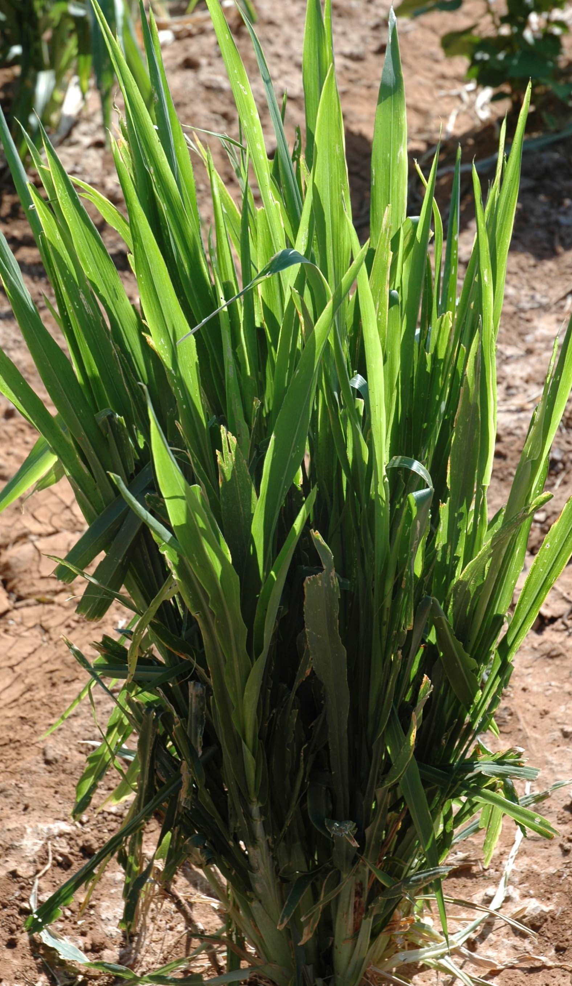
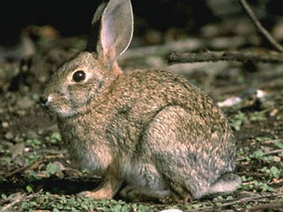
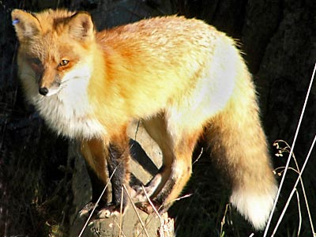

Plants: | _______ |  | Rabbits: | ________ |  | Fox: | 100__
About how many plants and rabbits do you think you would need to support a large number of foxes (around 100 foxes)? Try predicting and explaining the number of rabbits and plants you need. Write your numbers above, and explain your reasoning in the space below.

Data Collection Table:

Trial | Start |  |  | After 50 Years
 | Grass | Rabbits | Foxes | Grass | Rabbits | Foxes
1
2
3
4
5
6
7
8
9
10
Name: _______________________________________ Period: ____ Date: ________

1. On your data collection table, circle your BEST attempt at creating an ecosystem with a large number of foxes.

2. Was the grass, rabbit and fox biomass always the same size throughout the game? Why or why not? What processes are causing them to change size?

3. For your BEST attempt (circled on your table above), what was the pattern of biomass size at the end of the game (after 50 years) between grasses, rabbits and foxes? Rank them from largest to smallest.

4. Results for the whole class. Look at the average biomass size across the whole class. What was the pattern of average biomass size between grasses, rabbits and foxes? Rank them from largest to smallest.

5. Why do you think you see these patterns?

Assessing Sunny Meadows Investigation Worksheet
Lesson 2, Activity 1
Organisms eat one another to obtain organic matter and chemical energy. In order for large numbers of organisms to survive there must be enough food (organic matter) for the organisms to eat. So all the fox in an ecosystem depend on having enough food—like rabbits—to eat.
Prediction: In this investigation you will try to create a large number of foxes by adjusting the number of plants, rabbits, and foxes in the ecosystem. Keep in mind that rabbits eat the plants, and the fox eat the rabbits, so all three organisms are connected.

Plants: | _______ |  | Rabbits: | ________ |  | Fox: | 100__
About how many plants and rabbits do you think you would need to support a large number of foxes (around 100 foxes)? Try predicting and explaining the number of rabbits and plants you need. Write your numbers above, and explain your reasoning in the space below.
Students will guess numbers based on the choices available in the Sunny Meadows interactive. They may have more plants than rabbits, and more rabbits than foxes, but they may not realize how many more plants and rabbits are needed than foxes. Student reasoning about this pattern may not be detailed until after Lesson 4.

Data Collection Table:
See sample data in “Sunny Meadows Class Results and Sample data.xlsx” Excel spreadsheet.

Trial | Start |  |  | After 50 Years
 | Grass | Rabbits | Foxes | Grass | Rabbits | Foxes
1
2
3
4
5
6
7
8
9
10

1. On your data collection table, circle your BEST attempt at creating an ecosystem with a large number of foxes.

2. Was the grass, rabbit and fox biomass always the same size throughout the game? Why or why not? What processes are causing them to change size?

The grass, rabbit and fox biomass sizes were changing throughout the game. Students may not be able to give all the reasons why the biomass sizes were changing. (The processes that cause them to change size include photosynthesis, eating, death, cellular respiration).

3. For your BEST attempt (circled on your table above), what was the pattern of biomass size at the end of the game (after 50 years) between grasses, rabbits and foxes? Rank them from largest to smallest.
Student answers will vary, but grasses are larger than rabbits, and rabbits are larger than foxes.

4. Results for the whole class. Look at the average biomass size across the whole class. What was the pattern of average biomass size between grasses, rabbits and foxes? Rank them from largest to smallest.
Student answers will vary, but grasses are larger than rabbits, and rabbits are larger than foxes.

5. Why do you think you see these patterns?
Students can express their ideas here about why they see these patterns. They won’t have a complete answer to this question until after Lesson 4.

Activity 2: Comparing Different Ecosystems

Guiding Question: What is the pattern of organic carbon pool size that happens in ecosystems?

Duration: 20 minutes

Learning Objectives:
Students will:
- Describe the “biomass pyramid” (producers > herbivores > carnivores as a consistent pattern in terrestrial ecosystems

Activity Description:
In Sunny Meadows, students observe pattern of organic carbon pool sizes for grasses, rabbits and foxes. In this lesson students observe the same pattern in producers, consumers and carnivores in four different types of ecosystems. Students also observe that the size of the soil organic carbon pool is larger than the producer pool.

Background Information:
In Sunny Meadows, the students observe a pattern of organic carbon pool sizes for grasses, rabbits and foxes. But it is important for students to see that this pattern exists in all ecosystems for all types of producers, consumers and carnivores. Additionally, students may be surprised to learn that the size of the soil organic carbon pool is often the largest pool of organic carbon in ecosystems.

Materials:
- Lesson 2 Activity 2 Comparing Different Ecosystems.pptx Slides 1-16

Directions:

1. Carbon pool sizes in different ecosystems
Tell students that Sunny Meadows was a simulation of an ecosystem. Ask them if they think the same pattern of organic pool sizes is the same in all ecosystems? In deserts? In prairies? Use Power point slides 2-4 in Lesson 2 Activity 2 Comparing Different Ecosystems.pptx to show that we can represent carbon pool sizes with numbers.
2. Student predict ecosystems with the largest organic carbon pools
Have students consider two ecosystems at a time, prairie vs. desert, and a cornfield vs. desert during slide 5 - 16. Students should jot down a prediction on a scrap of paper. Which ecosystem will have the most organic carbon? They could also write down the pool that they think will be the biggest.
3. Comparing ecosystems
Use Power point slide 14 to have students write down as many observations as they can about the differences between the four ecosystems. The main thing they should notice is that the pattern in sizes of ecosystem pools is the same across ecosystems, where the largest pool is the soil organic carbon, then producers, then consumers then carnivores. They may also notice that soil organic carbon is largest in the prairie, but the forest has the most organic carbon in producers. You may use this opportunity to talk about how pool sizes are different because of the history of the site (lots of grasses growing and dying increase the soil organic carbon pool) and the size of the organisms that live there (trees versus corn plants). Use slide 15 to remind students of the unanswered question that they will discover in Lesson 3.

Lesson 3: Matter Cycles and Energy Flows In Ecosystems

Role of the Lesson in the Unit Sequence:
Activity 1-3:
Activity 4-5: Modeling in the application sequence for ecosystem-level processes

Duration: ~200 minutes
Activity 1: The Three Questions ~15 minutes
Activity 2: Carbon Dice Game ~30 minutes
Activity 3: Tracing Carbon: The Answer to the Carbon Question ~30 minutes
Activity 4: Tracing Energy: The Answer to the Energy Question ~30 minutes

Guiding Question: How do carbon atoms and energy move through an ecosystem?

Learning Objectives:
Students will:
- Share and record the classes’ initial ideas about the Three Questions at the Large-Scale
- Observe how carbon cycles and energy flows through an ecosystem
- Describe carbon cycling within ecosystems as movement of carbon atoms among carbon pools associated with: 1) Movement of materials (eating, defecation, death) and 2) Carbon-transforming processes (combustion, photosynthesis, digestion, biosynthesis, cellular respiration)
- Identify energy transformations involved in carbon fluxes and describe energy as flowing through ecosystems, from sunlight to chemical energy to heat that is radiated into space.

Lesson Description:
In this lesson, students are introduced to the Three Questions at a Large-Scale Framework. They will find that the first question, the Location Question, was answered during Lesson 2. The second and third questions, the Carbon/Movement Question and the Energy Question, are answered in the activities of Lesson 3. Students are introduced to how carbon cycles and energy flows in an ecosystem by playing the Carbon Dice Game and then practices answering the Three Questions at a Large-Scale.

Background Information:
The Carbon Dice Game helps students think about how carbon is cycled through different organisms in an ecosystem, and the processes that contribute to the transformation of carbon from one form to another: eating, digestion, biosynthesis, photosynthesis, cellular respiration and death/defecation. The game models the partitioning of matter in individual organisms into digestion/biosynthesis, cellular respiration, being eaten or death/defecation. The activity uses dice to represent the likelihood of a given carbon atom to be used to build mass in an organism or to be released back into the atmosphere as a product of cellular respiration. Students record their visit to carbon pools by making a tally mark on papers placed at each pool. In activities that follow the game, they are asked to consider the Carbon/Movement Question and Energy Question of the Three Questions at the Large-Scale to answer that carbon cycles and energy flows in ecosystems. The Carbon Game also supports the general pattern students observed in Sunny Meadows (that plants contain the largest biomass, followed by rabbits, then foxes), however in this simulation the Atmosphere and the Soil Organic Carbon pools are introduced, which are two significant carbon pools in the ecosystem.

By answering the Carbon/Movement Question and Energy Question students will notice that carbon atoms move between pools via carbon transforming processes and that when one pool increases, another pool must decrease. They will also observe that not all matter from lower trophic levels is passed on to consumers at higher trophic levels, and instead a lot of carbon ends up in the atmosphere and in soil organic carbon. Students will observe how energy is transformed from sunlight to chemical energy in producers and transferred between organisms during eating and death, and then transformed into heat energy during cellular respiration in an ecosystem.
Materials:
Activity 1
- Lesson 3 Activity 1 Intro to the Three Questions.pptx slides 1 – 9
Activity 2
- Lesson 3 Activity 2 Carbon Dice Game.pptx slides 1-15
- Pool Posters Carbon Dice Game Pools.pdf (Note: You may want to print more than one Pool Posters and Pool Tally Marks sheets and Energy Labels for the Atmosphere, Producer and Soil. These are very busy locations during the game and printing multiple posters and tally mark sheets allows multiple students to be at the pool at the same time).
- Pool Tally Marks.docx at least one copy per class period
- Energy Labels.docx at least one copy per classroom
- Yellow twist ties, at least 300 (although it is not necessary to the count twist-ties and quantify them before and after the game)
- Containers to put twist ties, at least one per each of the 5 pools
- 1 Die for each student
- 1 Pen/Pencil for each student (Note: you may choose to have students work in pairs, especially for younger students who may have difficulty managing the tasks of the game)
- Carbon Dice Game Class Results and Sample Data.xlsx Excel spreadsheet
Activity 3
- Lesson 3 Activity 1 Intro to the Three Questions.pptx Power point slides where student ideas about the Location Question and Carbon/Movement Question have been collected (slide 5 and slide 7).
- Lesson 3 Act 3 and 4 Answers to the Three Questions.pptx Power point slides
- Tracing Carbon Paths Worksheet, per student
- Carbon Dice Game Class Results and Sample Data.xlsx Excel spreadsheet
Activity 4
- Lesson 3 Activity 1 Intro to the Three Questions.pptx Power point slides where student ideas about the Location Question and Carbon/Movement Question have been collected (slide 5 and slide 7).
- Lesson 3 Act 3 and 4 Answers to the Three Questions.pptx Power point slides
- Tracing Energy Worksheet, per student
- Three Questions: Large Scale Questions, handout per student (optional)

Activity 1: The Three Questions at the Large-Scale

Duration: 15 minutes

Guiding Question: How do carbon atoms and energy move through an ecosystem?

Learning Objectives:
Students will:
- Share and record the classes’ initial ideas about the Three Questions at the Large-Scale

Activity Description:
In this lesson, students are introduced to the Three Questions at a Large-Scale Framework. They will find that the first question, the Location Question, was answered during Lesson 2. The second and third questions, the Carbon/Movement Question and the Energy Question, are answered in the activities of Lesson 3 (Activity 2-4).

Background Information:
In these lessons, students are introduced to how carbon cycles and energy flows in an ecosystem by playing the Carbon Dice Game and answering the Three Questions at a Large-Scale.

By answering the Carbon/Movement Question and Energy Question (in Activity 3 and 4) students will notice that carbon atoms move between pools via carbon transforming processes and that when one pool increases, another pool must decrease. They will also observe that not all matter from lower trophic levels is passed on to consumers at higher trophic levels, and instead a lot of carbon ends up in the atmosphere and in soil organic carbon. Students will observe how energy is transformed from sunlight to chemical energy in producers and transferred between organisms during eating and death, and then transformed into heat energy during cellular respiration in an ecosystem.

Materials:
- Lesson 3 Activity 1 Intro to the Three Questions.pptx slides 1 – 9

Directions:
1. Introduce the Three Questions at the Large-Scale
Use slides 2-3 of Lesson 3 Activity 1 Intro to the Three Questions.pptx Power point to tell students that a good explanation of carbon-transforming processes at a large-scale (the size of an ecosystem or bigger) must address three questions. These are questions that scientists also try to answer about chemical changes in ecosystems.
2. The Location Question
Use slide 4 to introduce the question “where are the available carbon atoms in ecosystems?” and “what pools of materials are they in?” Students should be able to answer this question completely from Lesson 1 and 2. New here is the rule to follow: carbon atoms stay in pools unless a process moves them in or out. We saw that pools changed size in Sunny Meadows, so that means carbon atoms must be moving. Use slide 5 to record student ideas about pools of materials that they find carbon atoms in ecosystems.
3. The Carbon/Movement Question
Use slide 6 to introduce the question “how/why do carbon pools change over time?” and “how are carbon atoms moving?” Students may have some ideas about these questions from previous Units about organisms. New here is the rule to follow: carbon-transforming processes move carbon atoms from carbon dioxide to organic molecules and back again. So there must be carbon-transforming processes occurring in ecosystems, but we have not yet explored what theses processes are. Use slide 7 to record student ideas about pools of materials that they find carbon atoms in ecosystems.
4. The Energy Question
Use slide 8 to introduce the questions “where does the chemical energy in ecosystems come from?” and “how is chemical energy transformed in ecosystems?” and “where does chemical energy go?” Students may have some ideas about these questions from previous Units about organisms. New here is the rule to follow: carbon-transforming processes change energy from sunlight to chemical energy to heat. Use slide 9 to record student ideas about pools of materials that they find carbon atoms in ecosystems.

Activity 2: Carbon Dice Game

Duration: 30 minutes

Guiding Question: How do carbon atoms and energy move through an ecosystem?

Learning Objectives:
Students will:
- Observe how carbon cycles and energy flows through an ecosystem

Activity Description:
Students play the Carbon Dice Game, acting out the pathways for carbon atoms and energy in a meadow ecosystem

Background Information:
The Carbon Dice Game helps students think about how carbon is cycled through different organisms in an ecosystem, and the processes that contribute to the transformation of carbon from one form to another: eating, digestion, biosynthesis, photosynthesis, cellular respiration and death/defecation. The game models the partitioning of matter in individual organisms into digestion/biosynthesis, cellular respiration, being eaten or death/defecation. The activity uses dice to represent the likelihood of a given carbon atom to be used to build mass in an organism or to be released back into the atmosphere as a product of cellular respiration. Students record their visit to carbon pools by making a tally mark on papers placed at each pool. In activities that follow the game, they are asked to consider the Carbon/Movement Question and Energy Question of the Three Questions at the Large-Scale to answer that carbon cycles and energy flows in ecosystems. The Carbon Game also supports the general pattern students observed in Sunny Meadows (that plants contain the largest biomass, followed by rabbits, then foxes), however in this simulation the Atmosphere and the Soil Organic Carbon pools are introduced, which are two significant carbon pools in the ecosystem.

Materials:
- Lesson 3 Activity 2 Carbon Dice Game.pptx slides 1-15
- Pool Posters Carbon Dice Game Pools.pdf (Note: You may want to print more than one Pool Posters and Pool Tally Marks sheets and Energy Labels for the Atmosphere, Producer and Soil. These are very busy locations during the game and printing multiple posters and tally mark sheets allows multiple students to be at the pool at the same time).
- Pool Tally Marks.docx at least one copy per class period
- Energy Labels.docx at least one copy per classroom
- Yellow twist ties, at least 300 (although it is not necessary to the count twist-ties and quantify them before and after the game)
- Containers to put twist ties, at least one per each of the 5 pools
- 1 Die for each student
- 1 Pen/Pencil for each student (Note: you may choose to have students work in pairs, especially for younger students who may have difficulty managing the tasks of the game)
- Carbon Dice Game Class Results and Sample Data.xlsx Excel spreadsheet

Advanced Preparation:
Post the Pool Posters around the classroom so that they are easily visible. The Atmosphere Pool should be represented by a large space in the classroom. The Producer Pool should take up an entire wall. The Soil Organic Carbon Pool should take up an entire wall. The Herbivore Pool should take up one corner of the classroom. The Carnivore Pool should take up a very small amount of space (one desk, for example). Label baskets for each pool with Energy Labels. Put many (at least 300) yellow twist-ties in the “Sunlight Energy” basket. Have an empty basket labeled “Heat Energy” near the Producer pool, the Herbivore pool, the Carnivore pool and the Soil Organic pool. Place the Pool Tally Mark sheets at each pool on a table so that they are easy to write on.

Directions:
- Explain the game
Use slides 1-9 of Lesson 3 Activity 2 Carbon Dice Game.pptx to introduce the Carbon Dice Game, tell them that they will each be a carbon atom that moves through an ecosystem and explain to students the rules of the game. Tell students that they are going to play a game that might help them think about the answer to the Carbon/Movement Question and the Energy/Movement Question. How are carbon atoms moving from one pool to another? How is chemical energy moving from one pool to another?
- Reminders for students
Before playing the game, distribute one die to each student (or pair of students). Show students where the pools are set up around the room. Model how to play the game by having one or two students roll the dice and move through the ecosystem a few times in front of the whole class. Be sure students understand when to pick up or drop off a twist tie and that a carbon atom can only have one twist-tie at one time. Twist ties are used only once, when some organism needs to use energy. Remind student to make a tally-mark every time they enter a carbon pool, or roll the dice and remain in a carbon pool. Ask the students if there are any questions.
- Play the game
Have all students start in the atmosphere pool as carbon in carbon dioxide molecules (that do not have energy, so no twist ties). Give students 10-15 minutes to play the game, record their data on the Pool Tally Mark sheets that are placed at each pool, and pick up energy twist ties at the Atmosphere pool (sunlight) and leave energy twist ties at the Producer, Consumer, Carnivore and Soil Organic Carbon pools (heat).
4. Collect the game Tally Marks
Have students collect the Tally Mark sheets from each station and add up the tally marks. Enter the number of tally marks in the Carbon Dice Game Results and Sample Data.xlsx file under the “visitations” tab. This will automatically generate a graph for your class. Use slides 10-13 of the PowerPoint to discuss some questions about the data that were collected from your class. Students might observe the same pattern that existed in Sunny Meadows. Students can compare their data to sample data from another class.
5. Observe the energy twist ties
Use Power point slides 14 – 15 to have students observe where the twist ties are now located in the ecosystem and to discuss some questions about what happened to the energy in the ecosystem. Students can observe the pattern of twist tie movement through the ecosystem, but do not need to count twist ties.

Activity 3: Tracing Carbon: The Answer to the Carbon/Movement Question

Duration: 30 minutes

Guiding Question: How do carbon atoms and energy move through an ecosystem?

Learning Objectives:
Students will:
- Describe carbon cycling within ecosystems as movement of carbon atoms among carbon pools associated with: 1) Movement of materials (eating, defecation, death) and 2) Carbon-transforming processes (combustion, photosynthesis, digestion, biosynthesis, cellular respiration)

Activity Description:
Students answer the Three Questions at the Large-Scale focusing on the Carbon/Movement Question.

Background Information:
By answering the Three Questions students will notice that carbon atoms move between pools via carbon transforming processes and that when one pool increases, another pool must decrease. They will also observe that not all matter from lower trophic levels is passed on to consumers at higher trophic levels, and instead a lot of carbon ends up in the atmosphere and in soil organic carbon. Students will observe how energy is transformed from sunlight to chemical energy in producers and transferred between organisms during eating and death, and then transformed into heat energy during cellular respiration in an ecosystem.

Materials:
- Lesson 3 Activity 1 Intro to the Three Questions.pptx Power point slides where student ideas about the Location Question and Carbon/Movement Question have been collected (slide 5 and slide 7).
- Lesson 3 Activity 3 and 4 Answers to the Three Questions.pptx Power point slides
- Tracing Carbon Paths Worksheet, per student
- Carbon Dice Game Class Results and Sample Data.xlsx Excel spreadsheet

Directions:
1. Revisit student ideas about the Carbon/Movement Question
Remind students of their ideas about the answers to the Carbon/Movement Question in the Three Questions at the Large Scale that were recorded in Lesson 3 Activity 1 Intro to the Three Questions.pptx slide 7. Tell students that they will be revising these ideas.
2. Pass out worksheets
Give each student a Tracing Carbon Paths worksheet Part I – III. Have students complete Part I on their own, and then compare with a neighbor to see if they both agree on all of the processes. Show Lesson 3 Activity 3 and 4 Answers to the Three Questions.pptx Power point slide 2 while they work. Afterwards, use slide 3 for student to check their answers.
3. Practice tracing carbon
Use slide 4 to discuss their answer to Part I of the worksheet. Then, with the class as a whole, practice tracing carbon in the scenarios in slide 5, 6 and 7 (What is the path a carbon atom would take to move from the atmosphere to a flower? What is the path a carbon atom would take to move from the atmosphere to the muscle of a rabbit? What is the longest path a carbon atom would take to move from the atmosphere to a decomposer?).
4. Draw arrows and processes
Open the Excel file Carbon Dice Game Class Results and Sample Data.xlsx and use the visitation data from the Carbon Dice Game to have the students put numbers in each pool in Part II of the worksheet. Use Power point slide 8 while students will fill out number 2-4 (arrows and processes) on the worksheet. Then, use slide 9 to compare to another class’s data.
5. The answer to the Carbon/Movement Question
Use slide 10 to remind students of the Carbon/Movement Question, and slide 11 to show students the answer to the Carbon/Movement Question. Have students compare this to the answer to number 4 on their worksheet.
6. Bridge to energy
Have students fill out Part III of their worksheets. Use these questions to have a discussion about how organic carbon molecules are needed for all living organisms (plants, animals and decomposers) for two reasons: to build new body parts (biosynthesis) and to use energy (cellular respiration).

Name: _____________________________________ Period: ____ Date: ________

Tracing Carbon Paths Worksheet
Lesson 3, Activity 3
Part I
You just spent some time as a carbon atom moving around a simple ecosystem. You probably moved from the atmosphere pool to the producer pool. Some of you may have become part of an herbivore, carnivore, or decomposer. Each of you took unique paths through the ecosystem. What does that path look like in a real ecosystem?

- Draw some arrows that show how carbon atoms can move from carbon dioxide in the atmosphere to organic matter in the ecosystem. Label these arrows with the letter “P” for photosynthesis.
- Draw some arrows that show how carbon atoms in organic matter move through the ecosystem during two processes: 1) Eating, label these arrows with an “E” and 2) Death or defecation label these arrows with a “D.” Make sure your arrows include:
  - Plants
  - Rabbits
  - The fox
  - The soil
- Draw some arrows that show how carbon atoms in soil organic matter can get back to carbon dioxide in the atmosphere. Label these arrows with the letters “CR” for cellular respiration.
- How are the arrows labeled “P” (from the atmosphere to the ecosystem) and “CR” (from the ecosystem to the atmosphere) different?
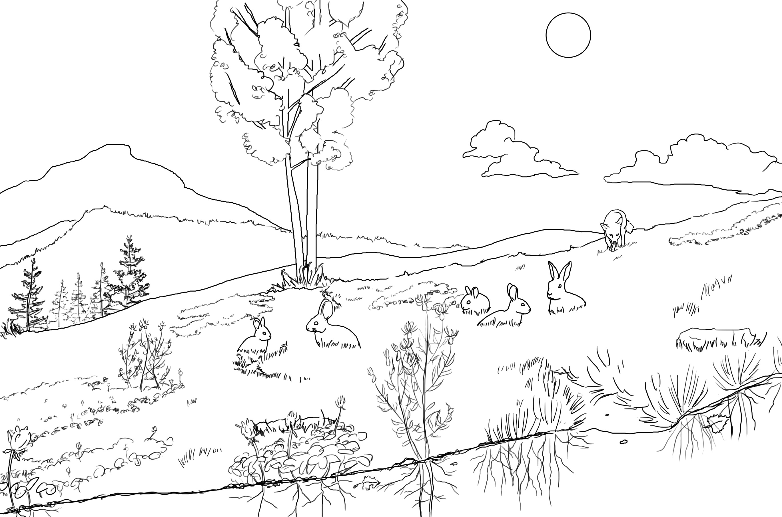

Part II.
1. Use the tally marks for each pool (visitation data) to fill in a number for each pool on the diagram below.
2. Draw arrows between pools.
3. Label each arrow with the process that moves carbon atoms from one pool to another.

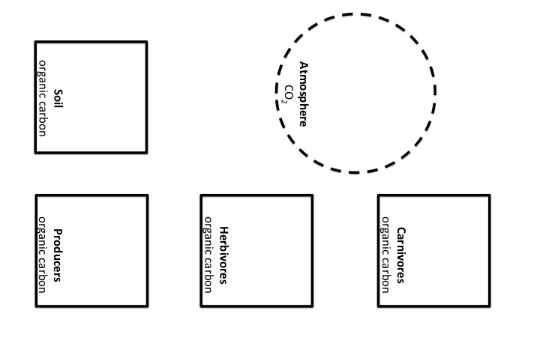

4. The answer to the Carbon/Movement Question:
How are carbon atoms moving from one pool to another?
- How are pools growing or getting smaller through carbon-transforming processes?
- What processes are involved?

Part III.

1. Why do plants do photosynthesis? (What is the purpose of photosynthesis for a plant?)

2. Why do animals do digestion?

3. Why do plants and animals do biosynthesis?

4. Why do plants and animals do cellular respiration?

Assessing Tracing Carbon Paths Worksheet
Lesson 3, Activity 3
Part I
You just spent some time as a carbon atom moving around a simple ecosystem. You probably moved from the atmosphere pool to the producer pool. Some of you may have become part of an herbivore, carnivore, or decomposer. Each of you took unique paths through the ecosystem. What does that path look like in a real ecosystem?

- Draw some arrows that show how carbon atoms can move from carbon dioxide in the atmosphere to organic matter in the ecosystem. Label these arrows with a P.
- Draw some arrows that show how carbon atoms in organic matter move through the ecosystem during two processes: 1) Eating, label these arrows with an E and 2) Death, label these arrows with a D. Make sure your arrows include:
  - Plants
  - Rabbits
  - The fox
  - The soil
- Draw some arrows that show how carbon atoms in soil organic matter can get back to carbon dioxide in the atmosphere. Label these arrows with an R.
- How are the arrows labeled P (from the atmosphere to the ecosystem) and R (from the ecosystem to the atmosphere) different?

See Lesson 3 Carbon Dice Game power point slide 16.

Part II.
1. Use the tally marks for each pool (visitation data) to fill in a number for each pool on the diagram below. Use the class data or sample data in the “Carbon Dice Game Class Results and Sample Data.xlsx” Excel worksheet.
2. Draw arrows between pools.
3. Label each arrow with the process that moves carbon atoms from one pool to another.

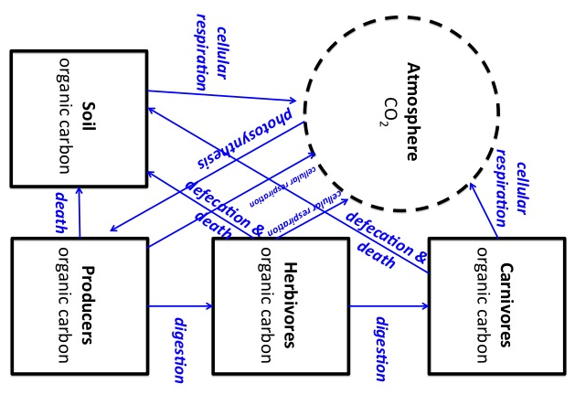

4. The answer to the Carbon/Movement Question:
How are carbon atoms moving from one pool to another?
- How are pools growing or getting smaller through carbon-transforming processes?
- What processes are involved?
Carbon cycles! Carbon-transforming processes (the ones in the diagram above) and death of organisms move carbon atoms form one pool to another. So carbon-transforming processes always increase the size of one pool while decreasing another.

Part III.

1. Why do plants do photosynthesis? (What is the purpose of photosynthesis for a plant?)
To make food to use for cellular respiration (a source of chemical energy for the plant) and to have materials to use for biosynthesis to build new body parts.

2. Why do animals do digestion?
To make food into small molecules so that they can be absorbed and made available to every cell in the animals body to use for cellular respiration (a source of chemical energy for the animal) and to have materials to use for biosynthesis to build new body parts.

3. Why do plants and animals do biosynthesis?
To take small molecules and build the big molecules that become the body parts of the plants or animals and allows the plants or animals to function.
Also, to store organic molecules like fat to be used for cellular respiration in the future.

4. Why do plants and animals do cellular respiration?
Because plant and animals need chemical energy for movement and the functioning of their cells and all body systems.

Activity 4: Tracing Energy: The Answer to the Energy Question

Duration: 30 minutes

Guiding Question: How do carbon atoms and energy move through an ecosystem?

Learning Objectives:
Students will:
- Identify energy transformations involved in carbon fluxes and describe energy as flowing through ecosystems, from sunlight to chemical energy to heat that is radiated into space.

Activity Description:
Students answer the Three Questions at the Large-Scale focusing on the Energy Question.

Background Information:
By answering the Carbon/Movement Question and Energy Question students will notice that carbon atoms move between pools via carbon transforming processes and that when one pool increases, another pool must decrease. They will also observe that not all matter from lower trophic levels is passed on to consumers at higher trophic levels, and instead a lot of carbon ends up in the atmosphere and in soil organic carbon. Students will observe how energy is transformed from sunlight to chemical energy in producers and transferred between organisms during eating and death, and then transformed into heat energy during cellular respiration in an ecosystem.

Note that the in describing energy flow students must add the energy source for all energy in ecosystems: sunlight. Note also that although the atmosphere is an important carbon pool, it is not an energy pool. A small amount of the heat energy from metabolic processes spends time in the atmosphere, but that heat energy is ultimately radiated into space in the form of infrared light (this is why the earth cools down at night). So while heat energy may move through the atmosphere (and some of it may temporarily be trapped in the atmosphere due to the greenhouse effect), eventually all of it will be lost from ecosystems, and flow into outer space.

Materials:
- Lesson 3 Activity 1 Intro to the Three Questions.pptx Power point slides where student ideas about the Location Question and Carbon/Movement Question have been collected (slide 5 and slide 7).
- Lesson 3 Activity 3 and 4 Answers to the Three Questions.pptx Power point slides
- Tracing Energy Worksheet, per student
- Three Questions: Large Scale Questions, handout per student (optional)

Directions:
1. Revisit student ideas about the Energy Question
Remind students of their ideas about the answers to the Energy Question in the Three Questions at the Large Scale that were recorded in Lesson 3 Activity 1 Intro to the Three Questions.pptx slide 9. Tell students that they will be revising these ideas.
3. Practice tracing energy
Use slide 13 – 19 in Lesson 3 Activity 3 and 4 Answers to the Three Questions s.pptx to help students think about the Energy Question and tracing energy. These slides are animated, so view in “slide show” mode for the best effect. Be sure to explain that all energy in the ecosystem is eventually converted into heat energy. Heat energy dissipates, moving through the atmosphere and ultimately is radiated into space.
4. Pass out worksheets
Give each student a Tracing Energy worksheet. Have students try to complete the first page on their own, and then compare with a neighbor to see if they both agree on all of the processes. Show Lesson 3 Activity 3 and 4 Answers to the Three Questions.pptx Power point slide 20 while they work. You may want to tell students to draw a sun on the worksheet to indicate the initial source of energy for ecosystems.
5. Draw arrows and processes
Show students the answers on slide 21. Have students make any revisions to their worksheets.
6. The answer to the Energy Question
Have students answer questions 4-7 on the second page of their worksheet based on what they just learned in the Power point presentation. Use slide 22 to show the answer to the Energy Question. Have students compare this to the answer that they wrote on their worksheet.
7. Check student understanding
Use slide 23 for students to answer the questions in pairs or in groups of four. Discuss the answers to the questions as a whole group. Give the student the Three Questions: Large Scale Questions handout as a reference.

Name: _____________________________________ Period: ____ Date: ________

Tracing Energy Worksheet
Lesson 3, Activity 5
1) Draw dashed arrows (- - - ->) to represent how energy flows through ecosystems.
2) Label each arrow with a form of energy.
3) Label the process that occur (photosynthesis, cellular respiration, eating, death and defecation), when energy changes form or location.

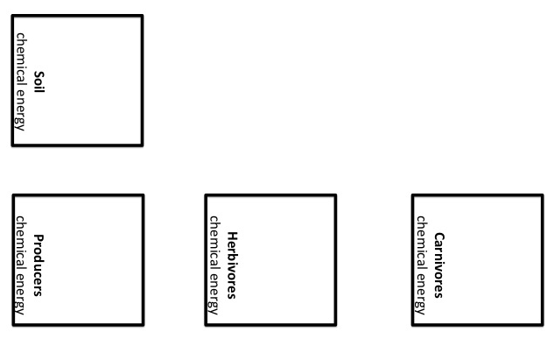

2) When energy is in the form of chemical energy, it is associated with matter in the form of a food (or fuel). Put a star on your diagram where matter and energy part ways. What is the name of the process that happens when matter and energy part ways?

The Answers to the Energy Question: Where does the chemical energy in ecosystems come from? How is it transformed? Where does it go?

4) Explain how energy is transformed into chemical energy when it enters an ecosystem:

5) Explain how chemical energy moves between ecosystem pools:

6) Explain how chemical energy is transformed when plants or animals use it:

7) Explain how chemical energy eventually leaves an ecosystem:

Name: _____________________________________ Period: ____ Date: ________

Assessing: Tracing Energy Worksheet
Lesson 3, Activity 5
1) Draw dashed arrows (- - - ->) to represent how energy flows through ecosystems.
2) Label each arrow with a form of energy.
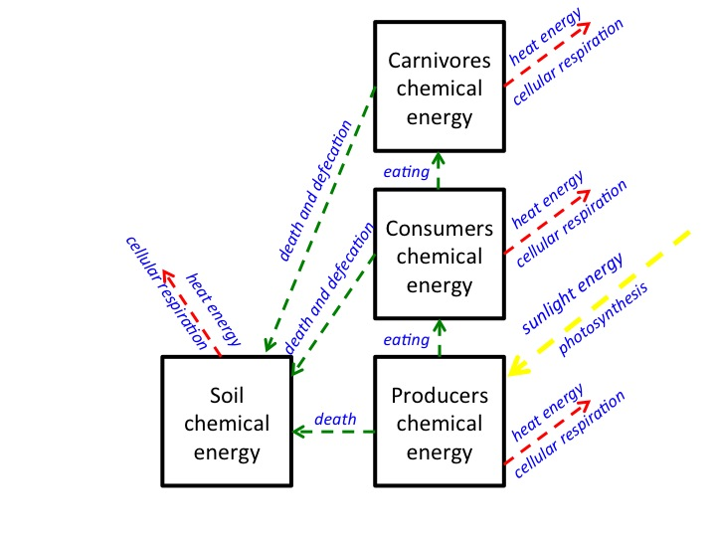
3) Label the process that occur (photosynthesis, cellular respiration, eating, death and defecation), when energy changes form or location.

2) When energy is in the form of chemical energy, it is associated with matter in the form of a food (or fuel). Put a star on your diagram where matter and energy part ways. What is the name of the process that happens when matter and energy part ways?

Cellular respiration

The Answers to the Energy Question: Where does the chemical energy in ecosystems come from? How is it transformed? Where does it go?

4) Explain how energy is transformed into chemical energy when it enters an ecosystem:
Through the process of photosynthesis, plants absorb sunlight energy and sequester it in C-C and C-H bonds of sugar molecules.

5) Explain how chemical energy moves between ecosystem pools:
Plant, animal and decomposer bodies are made of molecules with chemical energy (C-C and C-H bonds). These organic materials move through the ecosystem when plants and animals are eaten, and when plants, animals and decomposers die or defecate undigested materials.
When organic materials move, they stay organic materials and still contain chemical energy.

6) Explain how chemical energy is transformed when plants or animals use it:
Plants, animals and decomposers do cellular respiration for all of their life processes. During cellular respiration, organic molecules like sugar are broken. High-energy bonds in sugar (C-C and C-H) are replaced by low energy bonds (C-O and H-O) and the chemical energy is released. This energy can be transformed into motion energy or heat energy.

7) Explain how chemical energy eventually leaves an ecosystem:
Eventually even motion energy is transformed into heat energy. This heat energy is lost from the ecosystem (and eventually radiates into outer space in the form of infrared radiation).

The Three Questions: Large Scale Version
Question | Rules to Follow | Evidence to Look For
The Location Question: Where are the available carbon atoms in our environment?  What pools of materials are they in? | Atoms endure.  Carbon atoms stay in pools unless a process moves them in or out. | The air has carbon atoms in CO₂  Organic materials are made of molecules with carbon atoms  - Fuels  - Living and dead plants and animals (including foods)
The Carbon/Movement Question: How/why do carbon pools change over time?  How are carbon atoms moving? | Carbon-transforming processes move carbon atoms among pools  Carbon atoms cycle within environmental systems | Evidence of carbon-transforming processes:  - organisms eating, growing, breathing, dying  - decay  - combustion  If a carbon pool size changes, that means carbon atoms moved
The Energy Question: What is happening to chemical energy?  How does energy flow through environmental systems? | Carbon-transforming processes change energy from:  - sunlight to  - chemical energy to  - heat radiated into space  Energy flows through environmental systems | We can observe indicators of different forms of energy  - Organic materials with chemical energy  - Light  - Heat energy  - Work or motion energy

Lesson 4: Carbon Pools And Fluxes

Duration:
Activity 1: Why are carbon pools different sizes? ~35 minutes
Activity 2: Carbon Pools and Fluxes ~40 minutes
Opt Activity 3: Measuring Carbon Pools and Fluxes Reading ~20 minutes

Guiding Question: How do carbon pools change over time?

Learning Objectives:
- Explain changes in size of carbon pools in terms of fluxes into and out of carbon pools
- Explain why the biomass pyramid is a consistent pattern in terrestrial ecosystems.

Lesson Description:

In Activity 1, students will follow how carbon pools change in size as carbon moves in and out of each pool due to eating, digestion, biosynthesis, photosynthesis, cellular respiration and death/defecation. The teacher will use a Powerpoint presentation as students keep an accounting on a worksheet.

In Activity 2, students will predict how carbon pool size changes over time with different fluxes. The teacher will use a Powerpoint presentation as students work through three “Rounds” of a worksheet. Students use “Carbon atom cards” (or blocks of 100 carbon atoms) to keep an accounting of carbon pool size changes over time due to changes in carbon fluxes.

In Activity 3, students are assigned a reading that helps them understand how carbon fluxes and carbon pools are measured in ecosystems.

Background Information:
In this Lesson, students will explain the reason for the pattern of size of carbon pools that was observed in Sunny Meadows and the Carbon Dice Game. In order to explain the “biomass pyramid” students need to think about movement of carbon in semi-quantitative ways. Most of the carbon that enters ecosystems as organic carbon during photosynthesis is used for cellular respiration (energy needs) in organisms and returns to the atmosphere. Because most of the organic carbon in a organism is used for cellular respiration (and much of it is lost during death and defecation), very little organic carbon is available to be passed from one level in a food chain to another.

In the Unit so far we have talked about the movement of carbon from one pool to another without specifically talking about time. Fluxes are the amount of carbon that moves over time. In this lesson we talk about the movement of carbon that occurs within one year (a flux) and how that influences the size of carbon pools over time. In this lesson we also simplify the number of pools to only organic carbon in living organisms and soil carbon and inorganic carbon in the atmosphere, and carbon transforming processes to only photosynthesis and respiration.

Scientists are very interested in carbon movement in ecosystems. There are many techniques that have been developed to measure how carbon in ecosystems changes location, how rates of carbon movement change, and how carbon pools change in size. This reading describes the work of one scientist who studies carbon pools and fluxes.

Lesson Materials:
Activity 1
- Why are carbon pools different sizes? Worksheet, 1 per student
- Lesson 4 Activity 1 Carbon Pool Sizes.pptx Power point
Activity 2
- Carbon Pools and Fluxes Worksheet, 1 per student
- Carbon atom cards, 1 per pair of students, cut out into 12 cards
- Lesson 4 Activity 2 Carbon Pools and Fluxes.pptx Power point
Opt Activity 3
- Measuring Pools and Fluxes Reading, 1 per student

Activity 1: Why Are Carbon Pools Different Sizes?

Duration: 35 minutes

Guiding Question: Why are carbon pools different sizes?

Learning Objectives:
Students will:
- Explain changes in size of carbon pools in terms of fluxes into and out of carbon pools
- Explain why the biomass pyramid is a consistent pattern in terrestrial ecosystems.

Activity Description:
In this activity, students will follow how carbon pools change in size as carbon moves in and out of each pool due to eating, digestion, biosynthesis, photosynthesis, cellular respiration and death/defecation. The teacher will use a Powerpoint presentation as students keep an accounting on a worksheet.

Background Information:
In this Lesson, students will explain the reason for the pattern of size of carbon pools that was observed in Sunny Meadows and the Carbon Dice Game. In order to explain the “biomass pyramid” students need to think about movement of carbon in semi-quantitative ways. Most of the carbon that enters ecosystems as organic carbon during photosynthesis is used for cellular respiration (energy needs) in organisms and returns to the atmosphere. Because most of the organic carbon in a organism is used for cellular respiration (and much of it is lost during death and defecation), very little organic carbon is available to be passed from one level in a food chain to another.

Materials:
- Why are carbon pools different sizes? Worksheet, 1 per student
- Lesson 4 Activity 1 Carbon Pool Sizes.pptx Power point

Directions:
1. Set up the power point and worksheets
Students will fill out a worksheet as you display a Power point presentation about carbon pools. Pass out a worksheet Why are carbon pools different sizes? to each student. Use slide 2 to talk about the pattern that they observed in Sunny Meadows and in the Carbon Dice Game. This pattern is sometimes called the “biomass pyramid.” In this activity students will answer why this pattern exists in all ecosystems. Use slide 3 to show that students will track 100 carbon atoms as they go from inorganic carbon in the atmosphere to organic carbon in living things.
2. Keeping track of numbers
Use slide 3 to show the two types of numbers that students must keep track of on their worksheets: the number of carbon atoms that moved and the number of carbon atoms that stayed. Use slide 5-6 as an example. Slides are animated so use in “slide show” mode for the best effect.
3. Track carbon through an ecosystem
The teacher should guide students through Power point slides 7-21 as students track the carbon atoms on their worksheets. Students should also write the name of the process that occurred. At the end of the Power point (slides 19-21) students can add and subtract to find the total number of carbon atoms left in each pool.
4. Discussion questions
Students should answer the questions on the second page of the worksheet. Use slide 22-24 to discuss the answer to the questions with the students.
Name: _____________________________________ Period: ____ Date: ________

Why are Carbon Pools Different Sizes? Worksheet
Lesson 4, Activity 1
During the power-point presentation,
1) Draw an arrow in the direction that the carbon atoms moved.
2) Write the name of the process that occurred when the carbon atoms moved.
2) Record the number of carbon atoms that moved.
3) Record the number of carbon atoms that stayed.

After the power point presentation:
1) Do the math! What is the total amount of carbon atoms in each pool?
2) Write the pools below in order from smallest to largest:

Pool: Number of Carbon Atoms:

smallest ________________ ________________

________________ ________________

________________ ________________

________________ ________________

largest ________________ ________________

2) For all the carbon atoms in the producers that become organic matter through photosynthesis, where do most of the carbon atoms go? Why?

3) For all the carbon atoms in the organic matter (grass) that are digested by rabbits in the herbivore pool, where do most of the carbon atoms go? Why?

4) Why does this pattern of relative pools sizes exist in ecosystems? Does it have anything to do with energy?

Assessing: Why are Carbon Pools Different Sizes? Worksheet
Lesson 4, Activity 1
During the power-point presentation,
1) Draw an arrow in the direction that the carbon atoms moved.
2) Write the name of the process that occurred when the carbon atoms moved.
2) Record the number of carbon atoms that moved.
3) Record the number of carbon atoms that stayed.

3
320
10
67
100
CR
CR
CR
P
Death
Eat, digest
Eat, digest
CR
Death, defecation
Death, defecation

After the power point presentation:
1) Do the math! What is the total amount of carbon atoms in each pool?
2) Write the pools below in order from smallest to largest:

Pool: Number of Carbon Atoms:

smallest Carnivores 3

Herbivores 10

Soil Organic Carbon 67

Producers 100

largest Atmosphere 320

2) For all the carbon atoms in the producers that become organic matter through photosynthesis, where do most of the carbon atoms go? Why?

Most of the carbon atoms go to the atmosphere. This is because the organism is doing cellular respiration. The organism needs a lot of energy to do its life processes, so most of the food made by plants is burned in cellular respiration in order to use chemical energy.

3) For all the carbon atoms in the organic matter (grass) that are digested by rabbits in the herbivore pool, where do most of the carbon atoms go? Why?

Most of the carbon atoms go to the atmosphere. This is because the organism is doing cellular respiration. The organism needs a lot of energy to do its life processes, so most of the food eaten by animals is burned in cellular respiration in order to use chemical energy.

4) Why does this pattern of relative pools sizes exist in ecosystems? Does it have anything to do with energy?

When living organisms need energy, they do cellular respiration. In cellular respiration organic molecules with C-C or C-H bonds are burned, resulting in carbon dioxide and water. Carbon dioxide is a gas which is released into the atmosphere.
(AND, animals are inefficient in the food that they eat. They only digest and use some of the carbon that they consume.)

Activity 2: Carbon Pools and Fluxes

Duration: 40 minutes

Guiding Question: How do carbon pools change over time?

Learning Objectives:
Students will:
- Explain changes in size of carbon pools in terms of fluxes into and out of carbon pools

Activity Description:
In this activity, students will predict how carbon pool size changes over time with different fluxes. The teacher will use a Powerpoint presentation as students work through three “Rounds” of a worksheet. Students use “Carbon atom cards” (or blocks of 100 carbon atoms) to keep an accounting of carbon pool size changes over time due to changes in carbon fluxes.

Background Information:
In the Unit so far we have talked about the movement of carbon from one pool to another without specifically talking about time. Fluxes are the amount of carbon that moves over time. In this lesson we talk about the movement of carbon that occurs within one year (a flux) and how that influences the size of carbon pools over time. In this lesson we also simplify the number of pools to only organic carbon in living organisms and soil carbon and inorganic carbon in the atmosphere, and carbon transforming processes to only photosynthesis and respiration.

Materials:
- Carbon Pools and Fluxes Worksheet, 1 per student
- Carbon atom cards, 1 per pair of students, cut out into 12 cards
- Lesson 4 Activity 2 Carbon Pools and Fluxes.pptx Power point

Directions:
1. Set up the power point and worksheets
Students will fill out a worksheet as you display a Power point presentation about carbon pools. Pass out a worksheet Carbon Pools and Fluxes to each student. Use slide 2-3 to show how we will simply the ecosystem to two pools and two processes in order to think about how pools change size over time. Students will track carbon atoms moving back and forth between the inorganic pool of carbon in the atmosphere, and the organic pool of carbon in the biomass (slide 4).
2. Introduce fluxes and pools changing size over time
Use slide 5 to introduce the idea of a flux. A flux occurs over a space of time. Here we will use one year as one unit of time. Students will record the fluxes, or the number of carbon atoms that move between pools in one year. Use slide 6 to talk about what it means when a carbon pool increases in size. That means that there are more living things!
3. Round 1 - 3 of carbon pools and fluxes
The teacher should guide students through Power point slides 7-24 as students track the carbon atoms on their worksheets. Each Round is a different scenario that is occurring in an ecosystem. Students should also write a prediction for how pool sizes will change after a few years with the given fluxes. Students can use their 12 carbon atom cards to help write their predictions.
4. Fluxes of carbon change during the seasons
Use slide 25 to discuss with your students how fluxes change depending on what is happening in an ecosystem. For another example, use Power point slide 26-29 to show students how carbon pool sizes can change during seasons within one year. Students may also model these with their carbon atom cards.
Name: ____________________________________________ Period: ____ Date: ________

Carbon Pools and Fluxes Worksheet
Lesson 4, Activity 2
Place squares of 100 carbon atoms in the inorganic and organic carbon pool. Move the squares of carbon atoms to represent the flux that occurs. Count the carbon atoms in each pool at the end of the game.

Round 1: Fluxes are balanced

Pools at the start:
Inorganic = 800 carbon atoms
Organic = 400 carbon atoms

Fluxes:
Photosynthesis = 200 per year
Respiration = 200 per year

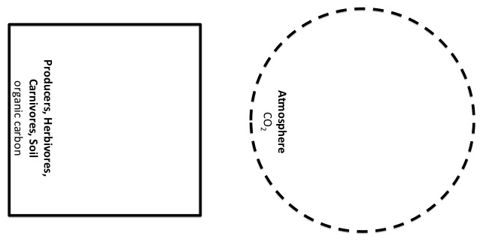
Circle the larger flux. Predict: how will the fluxes affect the size of the pools after a few years?

Round 2: Trees were planted in an abandoned cornfield

Pools at the start:
Inorganic = 800 carbon atoms
Organic = 400 carbon atoms

Fluxes:
Photosynthesis = 300 per year
Respiration = 200 per year

Circle the larger flux. Predict: how will the fluxes affect the size of the pools after a few years?

Round 3: Drought!

Pools at the start: Fluxes:
Inorganic = 800 carbon atoms Photosynthesis = 100 per year
Organic = 400 carbon atoms Respiration = 200 per year

Circle the larger flux. Predict: how will the fluxes affect the size of the pools after a few years?

Carbon Atom Cards

Assessing Carbon Pools and Fluxes Worksheet
Lesson 4, Activity 2
Place squares of 100 carbon atoms in the inorganic and organic carbon pool. Move the squares of carbon atoms to represent the flux that occurs. Count the carbon atoms in each pool at the end of the game.

Round 1: Fluxes are balanced

Pools at the start:
Inorganic = 800 carbon atoms
Organic = 400 carbon atoms

Fluxes:
Photosynthesis = 200 per year
Respiration = 200 per year

Circle the larger flux. Predict: how will the fluxes affect the size of the pools after a few years?
Answers may vary for prediction. Here the pools will remain the same size after a few years.

Round 2: Trees were planted in an abandoned cornfield

Pools at the start:
Inorganic = 800 carbon atoms
Organic = 400 carbon atoms

Fluxes:
Photosynthesis = 300 per year
Respiration = 200 per year

Circle the larger flux. Predict: how will the fluxes affect the size of the pools after a few years?
Answers may vary for prediction. Here the organic carbon pool will increase, and the inorganic carbon pool will decrease after a few years.

Round 3: Drought!

Pools at the start: Fluxes:
Inorganic = 800 carbon atoms Photosynthesis = 100 per year
Organic = 400 carbon atoms Respiration = 200 per year

Circle the larger flux. Predict: how will the fluxes affect the size of the pools after a few years?
Answers may vary for prediction. Here the organic carbon pool will decrease, and the inorganic pool will increase after a few years.

Optional Activity 3: Measuring Carbon Pools and Fluxes Reading

Duration: 20 minutes

Guiding Question: How do carbon pools change over time?

Learning Objectives:
Students will:
- Explain changes in size of carbon pools in terms of fluxes into and out of carbon pools

Activity Description:
Students are assigned a reading that helps them understand how carbon fluxes and carbon pools are measured in ecosystems.

Background Information:
Scientists are very interested in carbon movement in ecosystems. There are many techniques that have been developed to measure how carbon in ecosystems changes location, how rates of carbon movement change, and how carbon pools change in size. This reading describes the work of one scientist who studies carbon pools and fluxes.

Materials:
- Measuring Pools and Fluxes Reading, 1 per student

Directions:
1. Assign reading
This optional reading is available to assign to students to read and discuss as a class to further explore the idea of pools and fluxes.
Name: ____________________________________________ Period: ____ Date: ________

Measuring Pools and Fluxes Reading

Carbon is the most important element for living things. Every single living cell on Earth–plants, animals and humans—is made with carbon atoms. Humans are about 18 % carbon atoms by weight, and a human being who weighs 150 pounds contains about 7 hundred trillion trillion carbon atoms (that’s 7 followed by 26 zeros!). That’s a lot of atoms. Carbon is such an important element that when scientists want to study large populations of living things (for example when they’re thinking about grasses in a meadow, or trees in a forest), scientists can study these living things just by counting carbon atoms. Looking at the world by counting carbon atoms allows scientists to think on a ecosystem-sized scale or even Earth-sized scale about where living things are located and how they change. Global climate change, for example, is causing lots of living things to change, and counting carbon on the landscape gives us important information about those changes.

In many ecosystems, one important place where lots of carbon atoms are located is in trees. Dr. Andres Schmidt at Oregon State University is an atom counter. He uses high-tech tools to measure carbon atoms, like 150 feet high towers that let him look out over the forest canopy. These towers count carbon atoms in the form of carbon dioxide (CO₂) molecules in the air, as well as keep track of meteorological conditions like moisture and temperature. There are more than fifty of these towers all across the United States in a network called AmeriFlux. These scientists want to know if forests can absorb extra carbon in the air due to fossil fuel combustion.

Scientists use special words, “pools” and “fluxes” when counting atoms. Carbon pools are reservoirs of carbon atoms in a particular part of the ecosystem, like plants, soils, animals or air. Pools are thought of as bigger than one individual animal or tree; for example, a pool could be all the grasses growing in a meadow ecosystem or all the rabbits living in a meadow ecosystem. In ecosystems we think of major pools of carbon as soil, plants, animals and air. Pools can be lots of different sizes, and scientists even talk about the “all the vegetation in the world” as one pool of carbon. Pools are usually measured by the mass of carbon in an area (for example, pounds of carbon per acre). Scientists like Dr. Schmidt also measure pools in lots of “low-tech” ways—they may actually walk through the forest measuring trees and fallen logs and collecting leaf litter! Since plants are about 50% carbon by dry weight, the scientists like Dr. Schmidt are able to estimate how many carbon atoms are in a pool just by measuring trees and collecting leaves!

Fluxes are movements of carbon from one pool to another over time. Carbon moves through ecosystems by the carbon-transforming processes that we have studied: photosynthesis, respiration, biosynthesis, digestion (and combustion!). Fluxes are “rates” because they are measured as the amount of carbon that moves from one pool to another in a particular unit of time (for example, pound of carbon per acre per year). A flux is usually measured on a big scale, just like pools. For example, when the sun is shining on a forest, scientists like Dr. Schmidt can actually detect photosynthesis as a movement of carbon from the air pool to plant pools. When trees take in carbon during photosynthesis, the CO₂ in the air decreases above the forest. This movement of carbon from one pool to another is a flux!

Dr. Schmidt has a useful analogy for thinking about pools and fluxes. You can imagine a pool of carbon atoms like water in a swimming pool. Fluxes could include water that comes into the pool (like water from a hose), or water that leaves the pool (like a drain at the side). The amount of water in the swimming pool might increase for two reasons: because water flows from the hose at a greater rate, or because flow out the drain slows down. There are also two reasons why the water in a swimming pool could decrease: the flow of water coming in from the hose could slow down or stop, or the flow of water out the drain could increase.

In forests, water coming from the hose is like carbon entering the forest pool during flux from photosynthesis, and water leaving through the drain is like carbon leaving the forest pool during flux from respiration. Forest pools increase or decrease depending on photosynthesis and respiration rates. For example, a forest may absorb 2000 pounds of carbon per acre per year in photosynthesis, but then respire 1,500 pounds of carbon per acre per year. That would leave 500 pounds of C in the forest pool. An “increase in the carbon pool” of a forest means that the living trees are growing faster than the dead trees are decaying!

Lesson 5: Ecosystems Applications

Duration:
Activity 1: Farm Ecosystems ~30 minutes
Activity 2: Landscape Changes and Carbon in the Ecosystem ~20+ minutes
Activity 3: Ecosystem Unit Post-test ~20 minutes

Guiding Question: How does carbon cycling apply to real-world situations?

Learning Objectives:
Students will:
- Explain the implications for resource use of humans eating meat or plant products: The same producers can support more humans as herbivores than as carnivores.
- Explain changes in size of carbon pools in terms of fluxes into and out of carbon pools

Lesson Description:
In Activity 1, students consider how many people can be supported on a vegetarian diet versus a meat-based diet. Students account for carbon in both of these situations on a worksheet, while following along with a PowerPoint presentation.

In Activity 2, students use historical aerial photos from Google Earth to apply their knowledge of carbon cycling in ecosystems to various situations. Students examine images and answer a set of questions. This activity could be a class discussion, homework, or a self-paced activity in a computer lab. This activity could also have a portion where students go outside to compare aerial photos to what they see on the landscape (optional).

The final activity for the Unit is a Post-test.

Background Information:
Students consider several real world situations to apply their understanding of ecosystems and carbon cycling. Thinking about real-world situations will help students practice their knowledge and help students understand the relevance of this topic.

Lesson Materials:
Activity 1
- Farm Ecosystem Worksheet, 1 per student
- Lesson 5 Farm Ecosystem.pptx Power point
Activity 2
- Google Earth (download in advance)
- A suggested reading about forest fires: http://environment.nationalgeographic.com/environment/natural-disasters/wildfires/
- A suggested video about forest fires (Fighting Fire with Fire):
http://video.nationalgeographic.com/video/environment/environment-natural-disasters/wildfires-env/us_fightingfirewithfire/
Activity 3
- Ecosystems Unit Pre- and Post-test per student

Activity 1: Farm Ecosystems

Duration: 30 minutes

Guiding Question: How does carbon cycling apply to real-world situations?

Learning Objectives:
Students will:
- Explain the implications for resource use of humans eating meat or plant products: The same producers can support more humans as herbivores than as carnivores.

Activity Description:
Students consider how many people can be supported on a vegetarian diet versus a meat-based diet. Students account for carbon in both of these situations on a worksheet, while following along with a Powerpoint presentation.

Background Information:
Students consider several real world situations to apply their understanding of ecosystems and carbon cycling. Thinking about real-world situations will help students practice their knowledge and help students understand the relevance of this topic.

Materials:
- Farm Ecosystem Worksheet, 1 per student
- Lesson 5 Farm Ecosystem.pptx Power point

Directions:
1. Set up the power point and worksheets
Students will fill out a worksheet as you display a Power point presentation about carbon pools in a farm ecosystem. Pass out a worksheet Farm Ecosystems worksheet to each student. Use slide 2-3 to talk about how farms are ecosystems too, and humans are part of ecosystems.
2. Where would you locate humans in the food chain?
Use slide 4 and 5 to discuss where humans should be placed in the diagram. Use slide 6 to ask the question, where do we get the greatest number of people with the least amount of food? We will say that we need at least 1 carbon unit to make one human (slide 7).
3. Keeping track of numbers
Students will track carbon atom units on their worksheets.
4. Track carbon through an ecosystem
The teacher should guide students through Power point slides 8-31 as students track the carbon atoms on their worksheets. Students should also write the name of the process that occurred. At the end of the Power point students can add and subtract to find the total number of carbon atoms left in each pool.
5. Discussion questions
Students should answer the questions at the bottom of the worksheet. Use slide 31 to discuss the answer to the questions with the students.
6. Practice the Three Questions
Use slides 32-35 to have the students practice answering the Three Question at the Large Scale in the context of a farm ecosystem.
7. Carbon in what you eat
As an optional activity, students could each bring in one item of food from home (half are assigned a vegetarian item and half are assigned an item with a meat product) and examine the ingredients (for a whole food like an apple, there is only one ingredient. For a processed food like a granola bar or a can of chef Boyardee ravioli, there will be more than one ingredient). Students trace the path of a carbon atom from the atmosphere to their food product, to the person who will eat it. Possible questions that could be used in this activity include:
- How many steps in the food chain does a carbon atom take to get to them?
- Where do photosynthesis, digestion, biosynthesis, and respiration play a role?
- Of all food items brought into class, which item had the least amount of carbon returned to the atmosphere through cellular respiration on its path through the food chain? (vegetable items)
- Of all food items, which required the cycling of the most amount of carbon (meat items).
- What are additional ways that carbon is released into the atmosphere when we eat food? (transportation of food, use of fertilizers and pesticides) How? (fossil fuels are burned in combustion of vehicles that transport food, fossil fuels are burned when energy is used to create fertilizer and other chemicals)
- How do our food choices affect the amount of carbon that is put into the atmosphere?

Name: _____________________________________ Period: ____ Date: ________

Farm Ecosystem Worksheet

During the power-point presentation,
1) Record the number of carbon atoms that moved.
2) Record the number of carbon atoms that stayed.
3) Record the number of carbon atoms in each pool at the end of the power point.

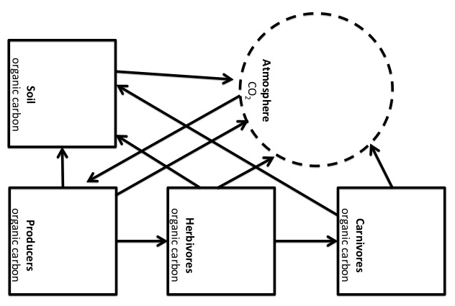

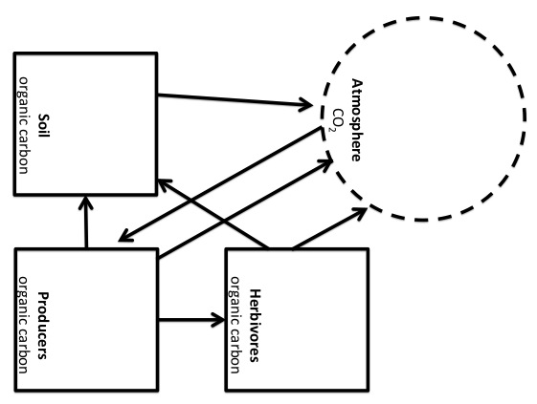

Herbivore diet Carnivore diet

1) Which diet can support more people? Why?

Activity 2: Landscape Changes and Carbon in Ecosystems

Duration: 20+ minutes

Guiding Question: How does carbon cycling apply to real-world situations?

Activity Description:
This activity uses historical aerial photos from Google Earth to give students a chance to apply their knowledge of carbon cycling in ecosystems to various situations. Students examine images and answer a set of questions. This activity could be a class discussion, homework, or a self-paced activity in a computer lab. This activity could also have a portion where students go outside to compare aerial photos to what they see on the landscape (optional).

Learning Objectives:
Students will:
- Explain changes in size of carbon pools in terms of fluxes into and out of carbon pools

Background Information:
Students consider several real world situations to apply their understanding of ecosystems and carbon cycling. Thinking about real-world situations will help students practice their knowledge and help students understand the relevance of this topic.

Additional resources:
These are less focused on carbon specifically, but may give ideas and resources for relating land-use changes and other events to carbon cycling:
- http://www.ei.lehigh.edu/eli/luc/index.html
- http://www.futurity.org/earth-environment/google-earth-engine-adds-time-lapse-video/
- http://www.crossingboundaries.org/birds-eye-view-of-changing-landscapes-1387.php
- From Local to Global: A Birds-Eye View of the Landscape by Courtney Wilson et al., The American Biology Teacher, Sept 2009
- A Land-Use-Planning Simulation Using Google Earth by Alec M. Bodzin and Lori Cirucci, Science and Children, Mar 2009.

Materials:
- Google Earth (download in advance)
- A suggested reading about forest fires: http://environment.nationalgeographic.com/environment/natural-disasters/wildfires/
- A suggested video about forest fires (Fighting Fire with Fire):
http://video.nationalgeographic.com/video/environment/environment-natural-disasters/wildfires-env/us_fightingfirewithfire/

Directions:
1. Look up an aerial photo of your school
In Google Earth find an aerial photo of your school either on a screen in front of the class, or as students using individual or group computers. Identify where the most carbon exists on the landscape. Have the students write or address as a class the following questions: What decisions have been made that have changed the amount of carbon that various spaces can hold? (How did the image of their neighborhood come to look the way it does?) How does carbon cycle through pools of carbon in the ecosystem in the picture? What decisions could be made to change our schoolyard? How would that change the way carbon is cycled in these spaces?
2. View changes in land-use of your school
Google Earth allows you to look at any historical images that exist in their database. To turn on this function select View>Historical Imagery and a slider bar should appear that allows you to “go back in time.” Check to see if there are any historical photos of your neighborhood.
You can also view historical photos of the meadow in Lesson 1 Activity 2 at 44°00'19.99" N 85°58'59.62" W in the Manistee National Park. This meadow is likely man-made since it didn’t exist before 2009.
Have the students write or address as a class the following questions: How have the pools of carbon changed in size over time in the images? Where does the carbon go when carbon pools change size?
3. View changes in land-use at other locations
You can also view dramatic land-use changes at other locations. Try looking at Las Vegas, Dubai, the coastline near Acheh, Indonesia before and after the tsunami in December 2004, New Orleans before and after Hurricane Katrina in August 2005, and Mt St. Helens before and after May 1980, and Rondônia, Brazil between 1975 and 2001.
Have the students write or address as a class the following questions: How have the pools of carbon changed in size over time in the images? Where does the carbon go when carbon pools change size? These examples all show a sudden decrease in carbon in ecosystems due to either natural or man-made events. What could happen to increase the size of carbon pools over time at these sites over time?
4. Forest fires
Have students read about a particular kind of landscape change: forest fires. Many people live in ecosystems that naturally have forest fires every 10 to 50 years. These fires are a way that nutrients are cycled back to soil, that allow for germination of some plant seeds, and allow some plants and animals to thrive. Helpful fires burn with low intensity and many plants and animals survive the fire. Fires are suppressed in many forests because the importance of fires to ecosystems was not well understood for many decades, and because many people have homes in these areas that burn. When fires are suppressed for a long time, dead plant material accumulates on the landscape. These dead dry logs, stumps, branches and twigs plants are fuels, and when a fire starts due to natural or man-made causes the fire is likely to become a wildfire. These fires burn very hot, more likely killing plants and animals and scorching the soil, and move quickly more often causing damage to homes. Discuss the following questions with the students and think about fluxes: How does carbon cycle through a forest that burns regularly? How does carbon cycle through a forest in which fires are suppressed? How does carbon cycle through a forest during a forest fire? How does carbon cycle through a forest after a fire?
5. Explore carbon on the landscape
If time and weather allows, students could go outside and compare what they see on the landscape with the aerial photo on Google Earth, paying close attention to carbon in the landscape. Students could select two different 1m x 1m plots in their schoolyard (lawn, garden, forest, any place with vegetation, etc). On these two plots they could describe where the carbon exists and compare the amount of carbon in each plot. They could trace the path of carbon in their plots. Possible questions to accompany this activity: Which plot do you think contains the most/least carbon? (i.e., a plot with sand vs. a plot with grass) How do you think the carbon atoms in your plot got there? What was at this spot 10 years ago, 50 years ago, 100 years ago? How could these plots be changed to contain more/less carbon? How long do these plots keep their carbon? (ie., a plot with a tree vs. a plot with only grass)

Activity 3: Ecosystems Unit Post-Test

Guiding Question:
What have students learned about carbon cycling and energy flowing in ecosystems?

Duration: 20 minutes

Activity Description:
Students retake the pretest that they took at the beginning of the unit and assess what they have learned.

Learning Objectives:
- Take a test that assesses most key learning objective for the unit.

Background Information:
The Post-test is a summative assessment activity. You can track students’ progress by having them retake the unit pre-test as a post-test and comparing the results of the two assessments.

Materials:
- Ecosystems Unit Pre- and Post-test per student

Directions:

- Pass out the unit post-test to each student.
They should be able to answer the questions correctly, so it is reasonable to grade them at this point.

Grading the Ecosystems Unit Pre- and Post-test
Lesson 5, Activity 3
Correct answers for grading purposes are suggested below.
1. Think about what might happen to carbon atoms and to energy in a forest. Decide whether each of the following pathways is possible or not:
Carbon atoms could leave the forest after they have been used by plants or animals. | Possible | Impossible
After carbon atoms have been used by plants or animals they could be recycled and used again by plants or animals. | Possible | Impossible
Energy could leave the forest after it has been used by plants or animals. | Possible | Impossible
After energy has been used by plants or animals it could be recycled and used again by plants or animals | Possible | Impossible
Explain your thinking. How are the possible pathways for carbon atoms and for energy alike and different?
Carbon atoms could leave the forest either by organisms that leave the boundaries of the ecosystem, or in carbon dioxide that mixes into the atmosphere. Once carbon atoms in a living thing go through cellular respiration and return to the atmosphere, they are available for photosynthesis and may re-enter a food chain. After organic materials go through cellular respiration, chemical energy is released as heat energy and could leave the ecosystem, eventually dissipated into outer space. After chemical energy is used by plants or animals it cannot be used again by plants in photosynthesis and re-enter the a food chain.

2. Your muscles are made of proteins, fats, and other materials that contain many carbon atoms. Think about where those carbon atoms came from.
Which of the following statements is true? Circle the letter of the correct answer.
a. ALL of the carbon atoms came into your body in food, OR
b. SOME of the carbon atoms were made by your muscles when your muscle cells grew and divided.
Circle the best choice to complete each of the statements about possible places where the carbon atoms in your muscles might have come from.
How many of the carbon atoms were once in the AIR? | All | Most | Some | None
How many of the carbon atoms were once in PLANTS? | All | Most | Some | None
How many of the carbon atoms were once in ANIMALS? | All | Most | Some | None
How many of the carbon atoms were once in DECOMPOSERS? | All | Most | Some | None
Explain your choices. How might the carbon atoms have gotten to your muscles?
Carbon atoms in the atmosphere in carbon dioxide are used by plants in photosynthesis. Humans eat plants (or animals that have eaten plants) and that is the way that carbon atoms enter our bodies. All carbon atoms in our body were once in plants, and in the air before that. Carbon atoms may have also been in animals or decomposers before they were in our food.

3. In a forest ecosystem, how would you expect the amount of carbon dioxide in the air to change in the summer. The amount of carbon dioxide in the forest air:
a. Would increase
b. Would decrease
c. Would stay about the same
Explain your answer. What would cause the amount of CO₂ in the forest air to change during the summer?
When photosynthesis occurs, more carbon atoms move from carbon dioxide in the air to plants. During the summer the rate of photosynthesis increases. Since atoms last forever, the overall amount of carbon dioxide in the atmosphere has to decrease.

4. In a forest ecosystem, how would you expect the amount of carbon dioxide in the air to change in the winter. The amount of carbon dioxide in the forest air:
a. Would increase
b. Would decrease
c. Would stay about the same
Explain your answer. What would cause the amount of CO₂ in the forest air to change during the winter?
When photosynthesis occurs, more carbon atoms move from carbon dioxide in the air to plants. When cellular respiration occurs, more carbon atoms move from living organisms to the air. During the winter the rate of photosynthesis decreases, and respiration either stays the same or decreases slightly. Since there are less carbon atoms entering plants compared to in the summer (and since atoms last forever), the overall amount of carbon dioxide in the atmosphere has to increase.
5. Here is a simple food chain with one plant, one animal, and some decomposers:
Grass | is eaten by | Rabbit | Dies and is  decomposed  by | Decomposing  bacteria
Answer true or false to the following questions:
True False The molecules in the rabbit came from the grass without changing.
True False The atoms in the rabbit came from the grass without changing.
True False The energy in the rabbit came from the grass without changing.
True False The bacteria recycle molecules from the dead rabbit back to the grass.
True False The bacteria recycle atoms from the dead rabbit back to the grass.
True False The bacteria recycle energy from the dead rabbit back to the grass.
Explain your answers: How do molecules, atoms, and energy move through the food chain?
Molecules might be destroyed during digestion and decomposition, but atoms remain the same. Atoms are rearranged into new molecules during digestion and decomposition. During digestion, chemical energy is transferred from the food to a new organism. During decomposition the bacteria use chemical energy in the molecules of dead organisms. Plants do not take up chemical energy from the soil. Instead, plants get energy from sunlight during photosynthesis.

6. A remote island in Lake Superior is uninhabited by humans. The primary mammal populations are white-tailed deer and wolves. The island is left undisturbed for many years. Select the best answer(s) below for what will happen to the average populations of the animals over time.
__X__a. On average, there will be more deer than wolves.
_____b. On average, there will more wolves than deer
_____c. On average, the populations of each would be about equal.
_____d. The populations will fluctuate, with sometimes more deer, sometimes more wolves
_____e. None of the above.
Please explain your answer to what happens to the populations of deer and wolves.
There will be more deer than wolves because as organic materials are eaten in a food chain, most of the food is used for cellular respiration (energy for the organism). One wolf will always need several deer (lots of organic carbon and chemical energy) in order to stay alive, and most of the organic carbon that makes up deer bodies will be respired by the wolf.

7. Answer these true-false questions:
True False Carbon is a kind of atom.
True False Carbon is a kind of molecule.
True False There is carbon in the air.
True False There is carbon in pure water.
True False There is carbon in the soil.

This statement simplifies chemists’ understanding of the nature of chemical potential energy. It would be more accurate to say that chemical potential energy is transformed to light and molecular motion (thermal energy) when organic materials are oxidized. In the Earth’s oxidizing atmosphere, however, reduced materials that can be oxidized are the limiting reactants in most environments, and C-C and C-H bonds signal the presence of reduced carbon and hydrogen.

